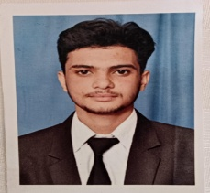
BHARAT BHUSHAN
RESUME
Email ID: sahilsanu35@gmail.com
Mobile no: 8219133180
Address: Vill. Garni P.O. KaloorTeh.Nadaun Distt, Hamirpur

- ACADEMIC QUALIFICATION :
- 10th from HPBOSE 54.4% marks
- +2 from HPBOSE 61.2% marks
- Bachelor in Vocational (Hospitality and Tourism)

- Experience :
- Three monts industrial training from Span Resort and Spa Manali.
- Eight months industrial training from Regenta Resort Exotica Dharamshala.

- Hobbies:
- Listening Music
- Travelling

- Personal Information:
- Father’s Name : Mr. Inderjeet
- Date of Birth: 05/11/2003
- Sex: Male
- Marital status : Unmarried
- Nationality : Indian

- Languages:
- English/ Hindi (Conversent)

- Declaration:
- The above mentioned information is true and correct to the best of my knowledge and belief.

BHARAT BHUSHAN

