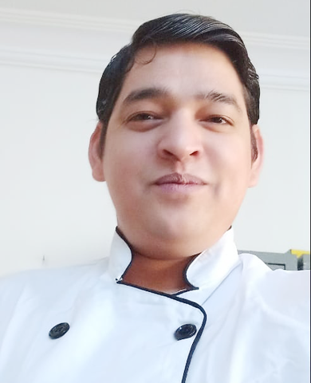

MANOJ SINGH
manojsingh66097@gmail.com

Contact Number:
+918422014205
PERMANENT ADDRESS:
Village- Jawari, Post-Mai Ki Mandi
District- Rudrarpayag
(Uttarakhand)
Pin Code- 246171, (Indian)

Date Of Birth
06-07-1995
Marital Stutus:
Single

Gender:
Male
Nationality
Indian

Religion:
Hindu
Religion:
Passport No-NA292936
Issue Date- 18/12/2015
Expiry Date- 17/12/2025
Place of Issue – Dehradun.
Languages Knowledge
English, Hindi

Date-02/06/2025
Place- Rudrarapayg.
To hard work for an organization which provides me the opportunity to improve my skills and knowledge to growth along with the objective and success with a company offering potential of challenge.
CURRICULUM VITAE
EDUCATION:
- Passed S.S.C. from UK Board in 2010 with 51%.
- Passed H.S.S.C. from Board in 2012 with 56%.
- Diploma in hotel Management from National Institute of hotel management Dehradun in 2016 with 50%.
INDUSTRIAL TRAINING :
- Completed 6 month Training from Hotel L.P. Residency, Dehradun from 4th may 2016 to 3 Nov. 2016.
WORK EXPERIENCE :
- Worked in Recently Nesto Hyper Market Saudi Arabia as a Indian Curry From 13th April 2023 to Till Date.
- Worked in Royal Goan Beach Club Goa as a Indian Curry DCPD from 25th Nov. 2022 to 4th March 2023.
- Presently working Carvella Beach Goa Resort as a Indian Curry DCPD From 20th September 2022.
- Working in Oxygen Resorts Goa as a Indian Curry DCPD from 15th July 2022 to 10th September 2022.
- Worked in Club Mahindra Vara Goa as a Indian Curry Commi-I from 15th May 2019 to 30th Jun 2020.
- Worked in Zuri White send Resort & Casino Varca Goa as a "Indian Curry Commi-II from 6th August 2018 to 6th April 2019.
- Worked in La Vida Varca by Sterling Holidays as a "Indian Curry Commi-III" 22th Feb 2017 to 6th August 2018.
- Worked as a Indian Curry Commi-I in Niyaaz Hotel in Belgum, Karnataka in the year 14th October 2014 to 15th April 2016.
STRENGTHS:
- Self –motivated hardworking and goal oriented with a high degree of flexibility creativity.
- Good in time management.
- Willingness to learn new things.
- Confident.
- Good in Communication skills.
- Friendly Nature.
- Good team work and coordination skills.
DECLARATION:
- I hereby declare that all the information mentioned above is true to the best of my knowledge .

(MANOJ SINGH)

