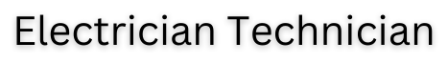




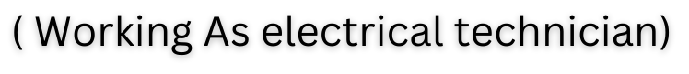


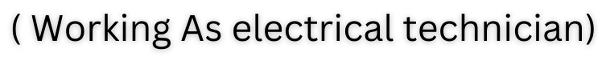



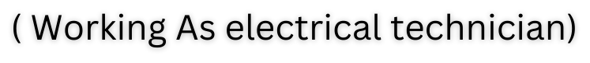



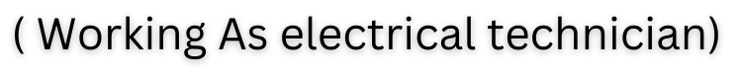



Mayank Enterprises Banswara
(Working As electrician technician )
Place : Banswara
02 May 2023 To 31 July 2024

Jaldhara Resort Kumbhalgarh
(Working As electrician technician Supervisor )
Place : Kumbhalgarh
Currently Working From 15 Aug 2024


