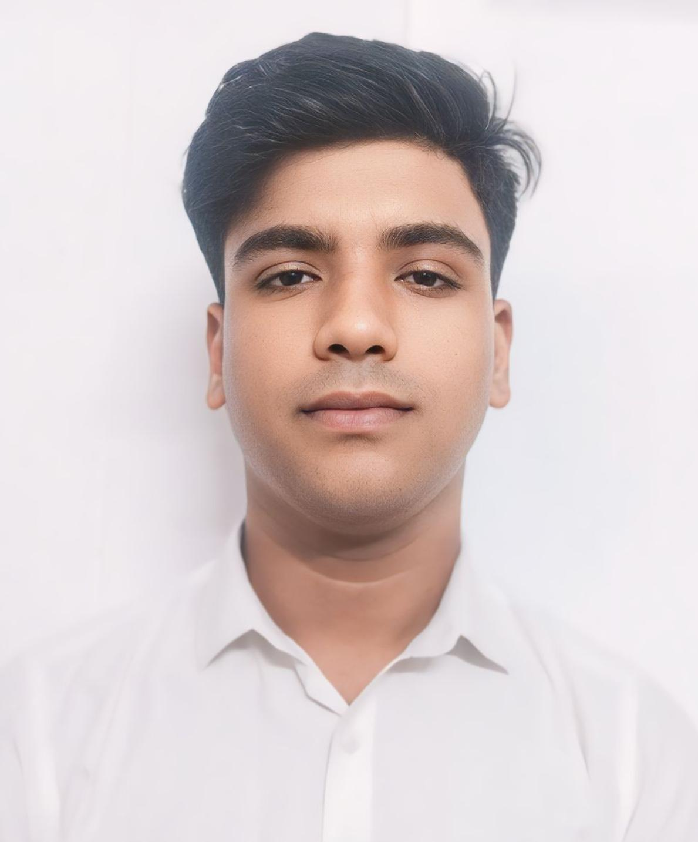
CURRICULUM VITAE

Mr. Md Muktada Hussain

- Ph No: +918250464187
- Email: muktadahussain18@gmail.com
- Address: Chakulia, Uttar dinajpur westBengal
Pin: 733208
- D.O.B: 13/09/2004

PROFESSIONAL GOALS:
An ambitious and a highly self- motivated individual is seeking for a deserving profile to build a career with a professional organization where I can utilize my training and interpersonal skills, while making a significant contribution to the success of the company.

WORK EXPERIENCE:
- Worked as a front desk associate in front office department at “Hablis Hotel Chennai”from March 2024 to May 2025.

EDUCATIONAL QUALIFICATIONS:
- Completed Diploma in Aviation, Hospitality & Travel Management in the Year 2024 from Frankfinn Institute, Siliguri.
- Passed Higher Secondary Education in the Year 2023 (Science stream).
- Passed Senior Secondary Education in the Year 2021

PROJECT AND I.T EXPERIENCE:
- “ Customer Interaction Project” done under Frankfinn, Siliguri
- Acquired knowledge & operation of “AMADEUS” software for ticketing and reservations.
- Gained knowledge and trained to be a Customer Service Professional.

SKILLS AND ABILITIES:
- Flexible and Adaptable.
- Possessing quick decision making ability for certain situations.
- Active Listener and a Good Communicator.
- Having Positive Attitude along with a courteous behavior.
- Having the ability to remain calm and patient to deal any situation.

I hereby declare that the above mentioned particulars are true to the best of my knowledge.

DATE:19/05/2025
Signature: Md Muktada Hussain

