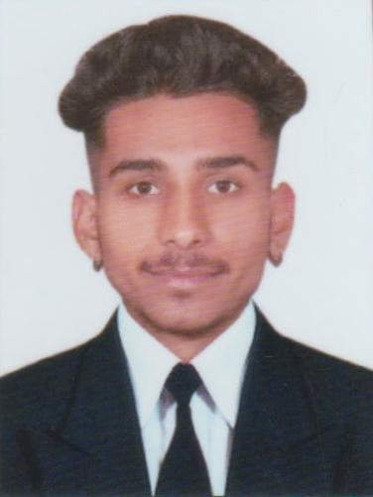 | Mohit  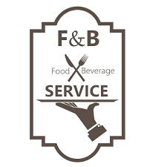 F&B Services Assistant

 20 Sep. 2003  Bir Naraina, Karnal  +91 9896625768  mohitrajput98966@gmail.com   0184-2250011 | Objective  A dedicated Professional having excellent knowledge of food production and skills related to the catering of guests seeks training in a reputed hotel to improve his skillest and uplift the hotel brand..
Academic Qualifications  + 12th Govt. Sr. Sec. School  In 2022, Bhadson, Karnal  +10th Sir Chottu Ram Memorial Sr. Sec. School, In 2020,  Bhadson, Karnal | Professional Qualification  2022 - Present  Diploma In Hotel Management . (F & B Services Assistant)  Wings Institute Of Hotel Management, Karnal, Haryana  - Learned about various cuisines and beverages.  - Learned how to use kitchen appliances including Microwave, Oven, Grill  - Learned Order taking skills.  - Learned Communication skills.  - Learned time management skills

Practical Explosure
- Completed 17 week Industrial Training from Hotel Almeida, Chandigarh.

Key Skills  Time Management  Decoration  Order Taking  Cleaning Silverware, Cutlery etc.  Responding to Requests of Guests | Roles and Responsibilities  - Attend meetings prior to the restaurant opening  - Order taking  - Clean and polish allotted silverware, cutlery, glassware, and chinaware.  - Decorate Table  - Present the bills and receive payments correctly.

Hobbies
- Music
- Movies

Date Name Signature

