Resume
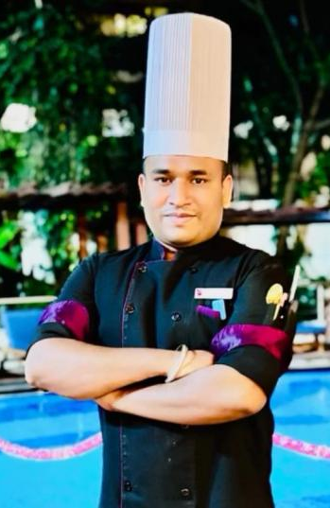
HARIOM
Date of Birth

02 APRIL 1993
Permanent Address:
# 50 NEW AZAD NAGAR JAAT MARKET
THANESAR KURUKSHETRA
Contact No: + 91 8929010209 ,7015359407
E-mail ; HM7069@GMAIL.COM
ABOUT MY SELF:
I am seeking a position in a dynamic organization with stimulating environment, where I could utilize my knowledge and education and face the global challenges ahead with the best of my performance and confidence.
AREA/ FIELD OF INTEREST:
- *Multi Cuisine
- *Specialisation in Continental Hot & Cold
WORK EXPERIENCE:

- Currently working at the Chancery Pavilion ,Bangalore ,as a Jr. Sous chef from 14th April 2022 till now.
- Assisted the chef in the all-food service operations & day to day operations of the kitchen.
- Provided direction to kitchen staff, ensured execution of all employee duties.
- Monitored kitchen operations to ensure compliance with health and fire department regulations.
- Ensured products were stored at the correct temperature and the recipe books were up to date with current menu items, portions & ingredients.
- Participated in the hiring process by conducting interviews & making hiring recommendations to the chef.
- Assured utilization of daily prep sheets & meat/fish yield sheet daily & that product counts were recorded accurately daily. Participated in monthly inventory process.
- Discussing & recommending menu with guest for party bookings.
- Over seeing theme decoration in coffee shop & lounge.
- Ordering vegetables & non- veg. for daily operations in kitchen .
- Maintaining FIFO in dry & cold storage of the kitchen.
- Market visits for updating on seasonal availability of ingredients.
- Kitchen staff training & taking orientation of new kitchen staff.

- Worked at BEST WESTEREN ABALA HARYANA , as a SEN C.D.P 12 MARCH 2021 to 05.03.2022.
- Implemented brunch menu in restaurant.
- Setting up new themes for dinner in barbeque nation.
- Taking care of banquet menu & recommending menus to the guest during one on one menu discussion.
- Ordering vegetables & non- veg. for daily operations in kitchen .
- Maintaining FIFO in dry & cold storage of the kitchen.
- Market visits for updating on seasonal availability of ingredients.
- Kitchen staff training & taking orientation of new kitchen staff.



- Worked at SAROVER PORTICO NEW DELHI as a chef De partie 24@43 restaurant from 17th July 2020 to 31st January 2021



- Worked at The RAMADA PLAZA CHANDIGARH as a DCDP in from 16th MAY2017 to 9th December 2019
- 

- Worked at LEMON TREE PREMIERE AERO CITY NEW DELHI as 1ST COMMI a Team Member from the 1st of MARCH 2016 to 9th APRIL 2017. 
- 

- Worked with RADISSON GREEN UDAIPUR as a GSA in from the 9th of APRIL 2015 to 21FEB 2016.
- 

- WORKED WITH NOOR MAHAL KARNAL HARYANA AS A COMMI  
PERSONAL ATTRIBUTES:
- Planning and execution
- Conflict and dispute resolution
- Maintaining Hygiene
- Maintaining good relationship with guest
- Extensive knowledge about the product
- Good Communication Skills,
- Ability to work in a group/team,
ACHIEVEMENTS
- Awarded as "Star of the month" during the month of November 2022 at The Chancery Pavllion Bangalore.
- HACCCP CERTIFICATE
• Awarded by certificates and trophy for securing positions in School Sports competitions.

Training
RADISSON BLU NEW DELHI
SAYA JI INDORE (M.P)

STRENGTH
Leadership, flexible, customer service, determined to work in a fast faced and challenging environment and good at time management.
QUALIFICATION:
•Degree in IHM Gurdaspur, Punjab -BSC IN- Hospitality and Hotel Administration Class- (2012-2015)
• Senior Secondary from GOVT VOCATIONAL EDUCATION INSTITUTE KURUKSHETRA HBSE BOARD(2011)
• Secondary Examination from GOVT SCHOOL HBSE Board (2009)

PERSONAL DETAILS:
Name : Mr HARIOM
Father's Name : Mr. RANDHIR SINGH
Mother's Name : Mrs. SHAKUNTLA DEVI
Date of Birth : 02 APRIL 1993
Gender : Male
Religion : Hindu
Marital Status : Married
Blood group : AB+
Languages Known : Hindi, English ,PUNJABI
Hobbies : Dancing, cooking, listening music, and painting

Decalaration:
I hereby declare that the above information is true and to the best of my knowledge.
Mr. HARIOM Place: Bangalore Signature*

