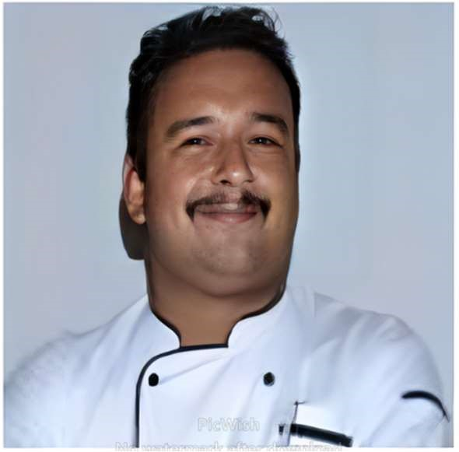
Dharmander Singh
53 Sanjay Colony, Guru Road Dehradun
Uttarakhand 248001
Phone: +917247845494
Email: dharmandersingh75@gmail.com
DOB:1st July 1975

Career Objective
To leverage my extensive experience and culinary skills in
the hotel industry while continuously learning and evolving as a professional. Aiming to
contribute to the success and growth of an esteemed establishment through innovative
gourmet presentations, exceptional kitchen management, and a commitment to food safety
and quality
Profile Summary & Core Competencies
- Gourmet presentations, Menu design, Kitchen management,
- Staff management; Team building, Inventory control Cost control/Reduction process
- Complaint resolution Communication Knowledge of HACCP & Food Safety.
Education
- 1992 – 1993 S.L.V. Inter college Dehradun
- Senior Secondary
- 1989 – 1990 SGRR Public school Dehradun
- Higher Secondary
Culinary Education
- Done Apprenticeship of three years from Hotel Madhuban Dehradun recognized by
Govt of India 1991-1994

Professional Experience

Feb 2025 till Now Park Regis hotel Goa (Executive Chef)
{Working as Executive Chef 114 Room Hotel with four outlets and biggest Convention Centre in goa
Responsible for Overall Operation of Kitchen Department and includes Menu Costing and Menu Designing}

Jan 2024--Jan 2025 Regenta Central Udaipur (Executive Chef)
{Working as Executive Chef 52 Room Hotel with two outlets and one Banquet Hall
Responsible for pre and post opening of rooftop restaurant on top floor named SORBO most happening place in town}

June 2023- Jan 2024 Park Plaza Ludhiana (Executive sous Chef)
{Working as task force chef in 96 plus room property with three outlet and Five Banquet
Hall}
Aug 21-May 23 Balaji Sarovar Premiere (Executive Sous Chef)
{Working as a Chef In charge in 129 Room Hotel with four outlets and four Banquet Hall
Responsible for Overall Operation of Kitchen Department and includes Menu Costing and
Organizing Food Festival, Staff Motivation & Skills, Working as HACCP Team Leader}

Feb 2019-Oct 2020 Daspalla Group of Hotel (Executive Sous Chef)
{Worked as Number two in 110 room property taking care of four Outlet and helping
Executive Chef in Menu development of Buffet as well as Menu planning for Convention Centre}

Dec 2017-Jan 2019 HMS host [Executive Sous Chef]
{Working as Executive Sous Chef with HMS in Goldman Sachs Bangalore having three wings
with seven outlet and buffet responsible for overall function that's include menu planning,
Weekly Grocery and daily perishable and butchery ordering, Guest Satisfaction, Cost Control
and working as HACCP Team Member}

Aug 2016-Sep 2017 Sodexo Food Solutions [Executive Chef]
{Worked as Chef Manager Responsible for Overall Operation of Food & Beverage
Department and includes Menu Planning, Weekly Grocery Ordering, Guest Satisfaction, Cost
Control and as QHSE Team Member}

July 2015-June 2016 Masala Bay Group Restaurant [Head Chef]
{Worked as Chef In charge of two restaurant of 125 and 45 covers serving North Indian,
South Indian, Chinese Developing the Alacarte menu as well as the weekend menu and overall aspects of Hygiene and Sanitation as HACCP Leader worked as PIC (Person In charge)

Dec 2012- June 2015 Daspalla Group of Hotel [Executive Sous Chef]
{Worked as Number two in 110 room property taking care of four Outlet and helping
Executive Chef in Menu development of Buffet as well as Menu planning for Convention
Centre}

July2011-Dec2012 Ramada Plaza Varanasi’ [Sous Chef]
{Worked as a Chef In charge in 120 Room Hotel with five outlets and four Banquet Hall
Responsible for Overall Operation of Kitchen Department and includes Menu Costing and
Organizing Food Festival, Staff Motivation & Skills, Worked as HACCP Team Leader}

July2010-June 2011 Taj View Hotel Agra [Senior Chef De Partie]
{Worked as Number Two in 100 room Property and a HACCP Coordinator here also and
Responsible for Overall Operation of three Outlet and Two Banquet Hall}

Dec 2007-June2010 Taj hotel Pasumalai Madurai [Chef de Partie]
{Worked as Number Two in 64 Room Property with two Outlets and one Banquet. Was a
HACCP team Coordinator and responsible for Overall Function of Outlets and Parties and
Cleaning and Sanitation as per HACCP Guidelines

Dec 2002-July 2007 Carnival Cruise Line, USA [Commi]
{Worked in Soup, Roast and Sauce Section]

Nov 1995-Nov 2002 Taj Palace Hotel, New Delhi [Commi 2nd]
{Worked in Coffee shop (Is fan), and Banquet Kitchen and was part of Opening Team of New
Restaurant Kafe Fontana from 2000 till 2002}

May 1995- Oct 1995 Gourmet Gallery New Delhi [Commi 3rd]
{Started my Career with a multicuisine restaurant worked in Continental & Grill section}

Area of specialization
- Indian
- Tandoor
- Continental
- Grill
Interests and Activities
- Sports
- Traveling
Languages
- English
- Hindi
Marital Status
- Married

