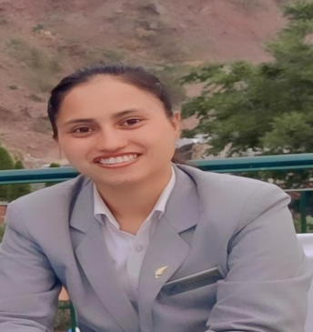_____________________________________________________________________________________
Name – Ms. Deepshikha
Contact number - 9568938970
E-mail – deepshikha0093@gmail.com
Apply For HR Executive
Career Objective

To work with an organization having conductive work culture, offering a responsible, challenging and creative work profile with continuous learning environment; where I can contribute my knowledge and skills towards the growth of the Organization, and further learn and gain exposure within the structured framework of the organization.
Job Profiles
Handling Payroll, Budgeting, Staffing, Statutory Processes, Recruitment, Adherence & implementation of SOP’s, Staff Welfare activities, MIS Report, Corporate social responsibilities and all HR functions.
ORGANIZATIONAL EXPERIENCE
The Fern Surya Resort, Kasauli Hills

HR Supervisor, from 14th June 2023, Promoted as an Executive HR January 2024 to till Date
- End to end joining formalities of new joiners.
- Issuing the appointment letter, ID cards & creating e-mail id of new joiners. Coordinate the induction program of new joiners.
- Perform administrative work, including scheduling, maintaining files & sorting mail for the Human Resources Department.
- Enter employment data into computer database.
- Coordinate HR projects (meetings, training, surveys etc) & take minutes.
- Deal with employee requests regarding human resources issues, rules & regulations.
- Working all formalities of HR like joining formalities, attendance, update data, maintain files etc.
- Conduct staff activities
.
Radisson Jaipur City Center, Jaipur
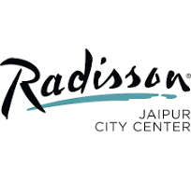
Job Trainee, Nov 2022 to April 2024
- Maintaining Employees Information by entering and updating employment and status change data.
- Explaining companies’ policies and procedures and benefits to employees or job applicants.
- Handled the overall recruitment process sourcing, screening, shortlisting the candidates etc.
- Arranging the Employees engagement activities.
- Taking care of employees’ data and records.
- Maintains Managers and employees confidence by keeping human resources information confidential.
- Handling the Mails and Calls
- Accommodation Handling
- Making Industrial training stipend list and roasters

Key Skills
- Excellent Communication
- Skills
- Able to do telephonic
- Screening interview.
- Employee Engagement
- Employee Relations
- Recruitment Operations
- Teamwork Candidate
- Sourcing Negotiation
- Interpersonal Skills

ACHIEVEMENT
- Appreciation Letter from Radisson Jaipur City Center.
- Best Trainee of the month.

EDUCATIONAL QUALIFICATION:
- Completed graduation in Bachelor of Commerce from Kumaun University, Uttarakhand.
- Completed 12th from Uttarakhand Board.
- Completed 10th from Uttarakhand Board

PROFESSIONAL QUALIFICATION:
- Diploma in Hotel Management from Aims Institute of Hotel Management at Haldwani, Uttarakhand
- Diploma in Computer Education.
PROFESSIONAL TRAINING
- Six month Industrial Training from Mohan Palaces Hotel, Haldwani, Uttarakhand
HOBBIES:
- Listening Music
- Travelling,
LANGUAGE KNOWN:
- Hindi
- English
PERSONAL DETAILS:
- Name: Ms. Deepshikha
- Father Name: Mr. Bijendra Singh Bhoriyal
- Date of Birth 05th September 2001
- Sex: Female
- Marital Status Unmarried
- Nationality: Indian

DECLARATION:
I hereby declare that the above mentioned information is true to the best of my knowledge and belief.

Date………. Deepshikha

