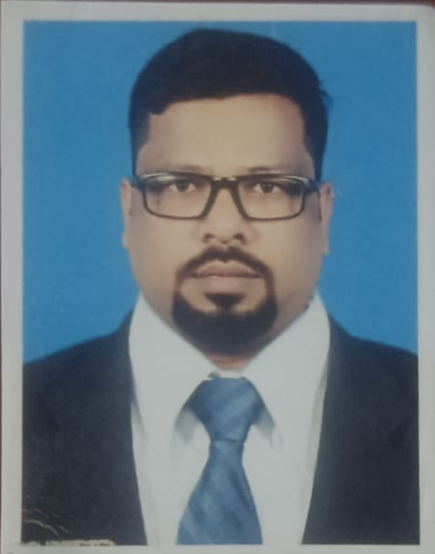
Career Objectives :
To excel and contribute to a growing industry with the culinary skills acquired and execute the menu,
ensuring a high level of performance, guest satisfaction and profitability while keeping up-to-date with
the latest in the field of hospitality industry to constantly enhance my potentials and performance
level and develop myself into one of the most resourceful individual for the organization.
Personal Information :
Father’s Name : Shri. Trilochan Dutta
Nationality : Indian
Date of Birth : 3rd November 1985
Mobile No. : +91 – 8080638875
E-mail ID : chefmsd@gmail.com
Permanent Address : Flat no. 1372, Sector – 6/D, Bokaro Steel City,
Bokaro, Jharkhand - 827006
Qualifications :
➢ Completed B.Sc In Hotel Management & Catering Technology Year - 2007
➢ Completed Intermediate From Central Board Of Secondary Education Year – 2004
➢ Completed Matriculation from Jharkhand Secondary Examination Board Year - 2002
Experience :
Hotel Lake View, Berhampore, Murshidabad, W.B
Executive Chef (March 2025 - Till Date)
Hotel Genista Inn, Ranchi, Jharkhand
Executive Chef (August 2024 – February 2025)
The Royal Retreat, Ranchi, Jharkhand
Executive Chef ( May 2023 – May 2024 )
Hotel Crowne Plaza, Pune
Executive Sous Chef ( January 2023 – April 2023 )
The 7A Restaurant & Bar, Pune, Maharastra
Executive Chef [ Multicuisine ] (November 2021 –December 2022)
Barrel Yan Tree, Candolim, Goa
Unit Executive Chef [Multicuisine] (January 2021- September 2021
18 Degrees Rooftop Resto Lounge, Pune
Executive Chef [Multicuisine] (September 2019 – Till Lockdown)
The Mafia, Viman Nagar, Pune
Executive Chef (Multicuisine) (August 2018 – August 2019)
18Degrees Rooftop Resto Lounge, Pune
Head Chef [Multicuisine] ( June 2016 – July 2018 )
18 Degrees Rooftop Resto Lounge, Pune
Sous Chef [ Multicuisine ] (May 2015 – June 2016)
Soul Konnect Hospitality, Mumbai
Sous Chef [Multicuisine] (November 2014 – May 2015)
Aamby Valley City, Lonavala
Chef De Partie [Mediterranean] ( 2012 – 2014)
Aamby Valley City, Lonavala
Demi Chef De Partie [Continental] (2010 – 2012)
Aamby Valley City, Lonavala
Commi – I [Continental] (2008 – 2010)
The Coronet Hotel, Pune
H.O.T – F&B Production (November 2007 – May 2008)
Majestic Park Plaza, Ludhiana
Trainee Commi-III [Continental] (December2006–September2007)
Ramada Caravella Beach Resort, Goa
Industrial Trainee 24 Weaks (October 2005- March 2006)
Achievements :
Successfully Completed FSSAI FOSTAC Food Safety Supervisor Training – 2024
Selected for the Black & White Blended Scotch Whisky promotional event 2016 for 18 Degrees.
Participated in the ‘Great Indian Culinary’ Challenge – 2013
Participated in the ‘Great Indian Culinary’ Challenge – 2012
Achieved ‘Executive of the year – 2012 award in Aamby Valley City
Successfully organized and executed various events hosted in banquets.
Earned valuable repeat and referral business based on excellent customer relations.
Trained new service staff to completely focus on delivering a quality customer experience.
Promoted higher quality liqueurs and specialty drinks to increase average sale per customer.
Introduced cost control initiatives, which significantly reduced operating expenses.
Practiced careful management and handling of stock to minimized waste and increase profits.
Delivered personal attention to customers to ensure high level of satisfaction, to generate repeat clientele,
- and to encourage word of mouth referrals.
Technical Skills :
Extensive knowledge and skills acquired in Mediterranean Cuisine
In depth knowledge and expertise gained in culinary skills for preparing Continental, Indian and Oriental Cuisine.
Personal Competency :
Optimistic attitude coupled with perseverance in achieving goal.
Demonstrated professional communication skills.
Ability to solve problems creatively and take effective decisions.
Ability to work collaboratively in a team and work well under pressure.
Highly motivated &organized to deliver quality service.
Staff Training.
Work effectively with diverse groups of people.
Able to make prompt and intelligent decisions.
Good team player and a leader.
Flexible in management capabilities.
Can communicate effectively.
Languages Known :
English
Hindi
Bangla
Disclaimer :
I hereby declare that all the above information furnished is true to the best of my knowledge and belief.
Date :
Place :
Yours Sincerely
Madhu Sudan Dutta

