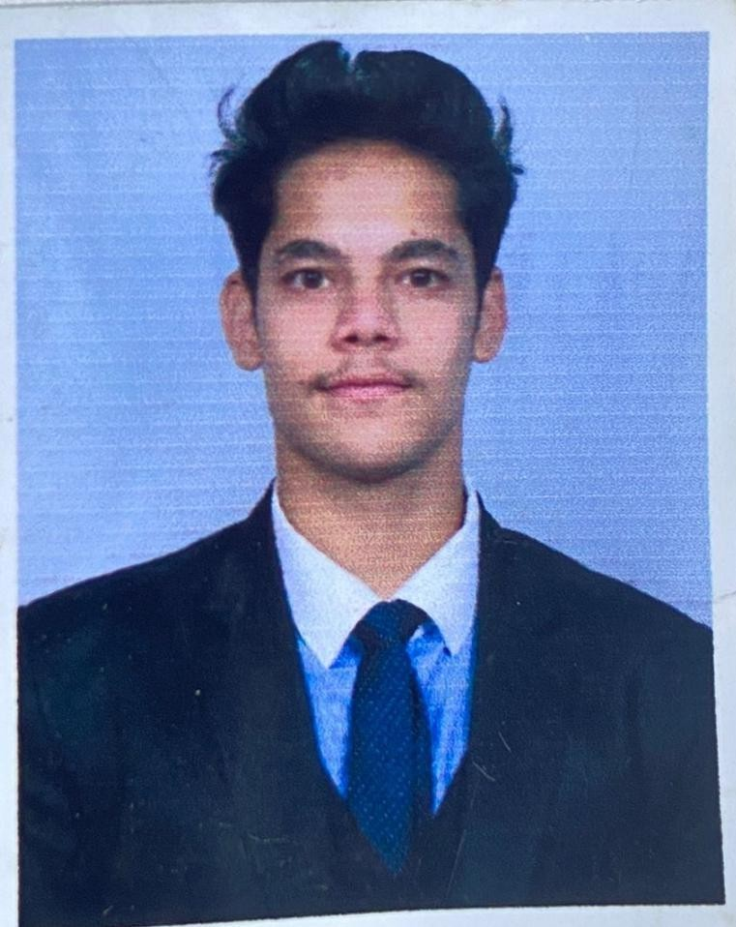

Akhilesh Birkhani
Address –Indra nagar 2, lalkuan, nainital Uttarakhand - 263159
Phone no.- +91 - 7298254805
E-Mail ID - ritikbirkhani@gmail.com

OBJECTIVE -
To be associated with a progressive organization which can provide me with a dynamic work sphere to extract my skills as a professional to achieve the organization goal.

PROFESSIONAL QUALIFICATION -
- Diploma in Hotel Management from Dr. Susheela Tiwari Institute of Hotel Management,Haldwani, Uttarakhand.(Year 2022-2023)
- Certified in ADVANCE TALLY (Mar 2022 - July 2022).

WORK EXPERIENCE -
- Undergoing the On-job Training form Le meridien Ahmedabad in front office department.
- Completed Industrial training from Farimont Jaipur (Nov 2022 - April 2023)

ACADEMIC QUALIFICATION -

- Passed Matriculation in the year 2019 from CBSE Board.
- Passed Intermediate in the year 2021 from CBSE Board.

AREA OF INTEREST-
- Front Office

STRENGTH-
- Optimistic
- Diligent
- Quick learner

HOBBIES-
- Creating Instagram reels/Modeling.
- Exploring new places

PERSONAL DETAILS -

Date of Birth : | 21/03/2002
Father’s Name : | Mr.Girish Chandra Birkhani
Nationality : | Indian
Marital Status : | Unmarried
Gender : | Male
Language Known : | English & Hindi | DATE…………..
 |  | [Akhilesh Birkhani]

