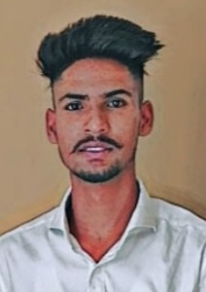
RESUME
Ajay Kumar
S/O:- Sh. Raj Kumar
Add:- New Basti Dhangu Peer
Near MH Gate KANGRA (H.P)
Contact No:- +91-7696435532
E-mail:- ajaykumar.ptk2003@gmail.com

CAREER OBJECTIVE:-
- To associate myself with an organization which provide me a Wide scope for learning and a Competitive job to utilize my capabilities towards the organization goals.

STRENGTH:-
- Hardworking, regularity & punctuality.
- Quickly absorb and retain new information and procedures.
- Possess team spirit with pleasant manner to develop and maintain good working relationship.

EDUCATIONAL QUALIFICATION:-

Class | Board | %age
10th | HPBOSE | 57.00%
12th | HPBOSE | 78.00%
BHMCT | A & M INSTITUTE OF COMPUTER & TECHNOLOGY | PERSUING

PERSONAL DETAILS:-

- Name : Ajay Kumar
- Father Name : Sh. Raj Kumar
- Date Of Birth : 02/05/2003
- Gender : Male
- Marital Status : Unmarried
- Nationality : Indian
- Language Known : English, Hindi & Punjabi
- Hobby : Travelling & Cooking Food & Playing Cricket

EXPERIENCE:-

- 6 months Industrial Training Experience Hotel Management in all Department in MARIGOLD SAROVAR PARTICO SHIMLA.
- 6 months experience in housekeeping Department in Hotel Fairmount.(Shimla)
- 6 months experience in housekeeping as a GSA in justa Birding Dharamshala.
- Presently I am working in ROYAL ORCHID REGENTA PLACE VERKA BY PASS in Housekeeping as a GSA.(AMRITSAR)

DECLARATION:-

I Ajay Kumar, hereby declare that the above particulars furnished by me are true to the best of my knowledge and belief.

Date:
Place: (AJAY KUMAR)

