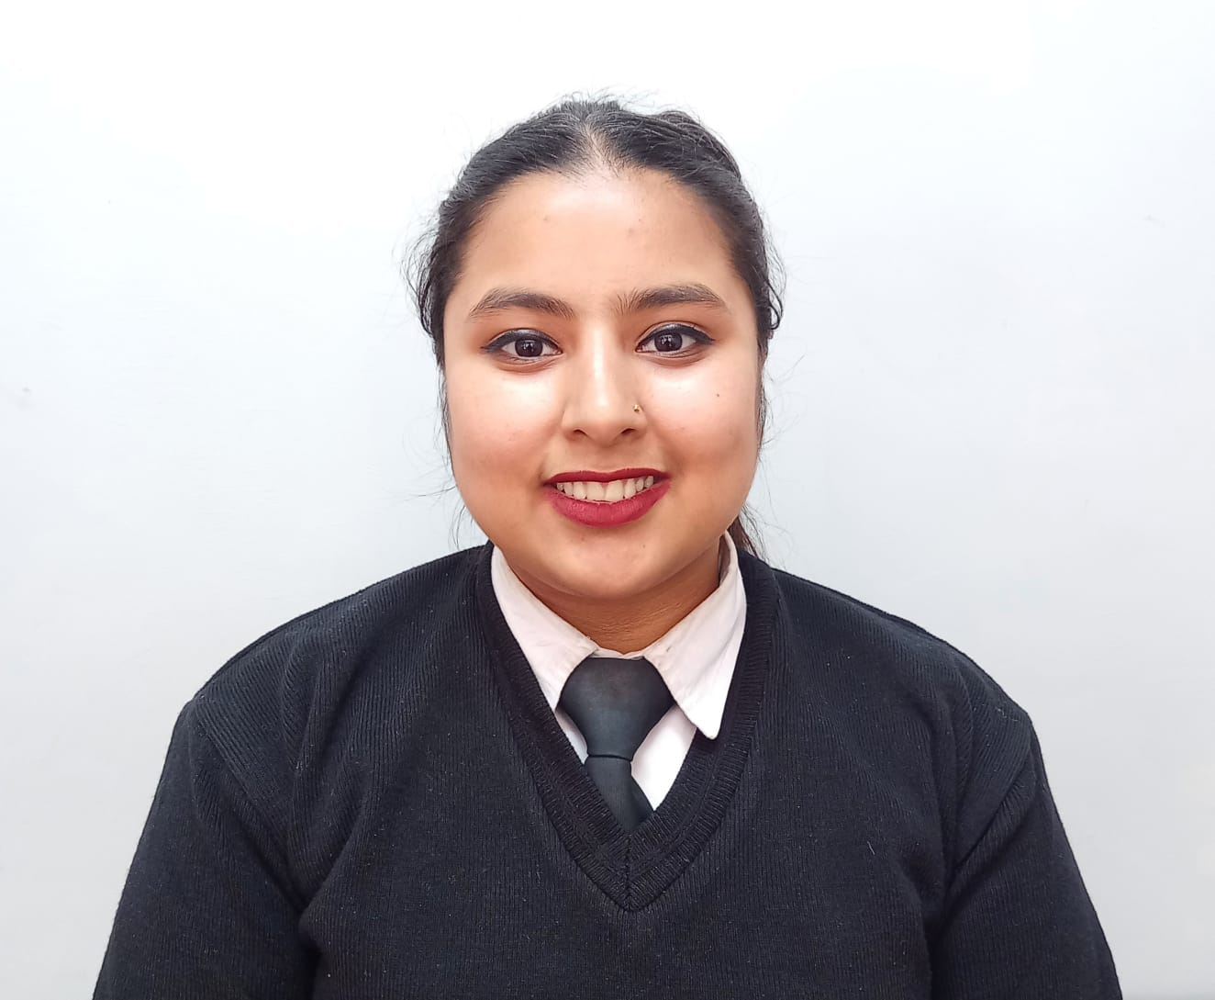
RESUME
VERSHA SHARMA

Phone: +91 9015029164
Email: vershasharma402@gmail.com
Address: Vill. Kufridhar P.O. Ghanahatti Teh. & Dist. Shimla.
Himachal Pradesh -171011
OBJECTIVE

Looking forward to a job of responsibility that enhances my skills and develop them with the best possible result and contribute to the growth of the company by putting to the best use my varied professional experience, skills and sincere hard work.

EDUCATIONAL QUALIFICATIONS

- Competed 10th Standard from HPBOSE.
- Competed 12th Standard from HPBOSE.

PROFESSIONAL QUALIFICSTION

- I am pursuing my Diploma In Hospitality Management from Shyamala Academy Of Hospitality Management, Shimla, Himachal Pradesh.

EXPERIENCE

- 6 Months industrial training from Courtyard By Marriott (Gujarat, Vadodara) in F & B Service.
- 6 Month work experience from Sarovar Portico Sonipat in F&B Hosstess.

PERSONAL STRENGTH

Hard working
Quick learner
Positive attitude
Sincerely

PERSONAL DETAILS

Father Name : Sh. PUNEET SHARMA
Date of Birth : 17/11/2005
Marital Status : Unmarried
Languages Known : Hindi, English
Gender : Female

DECLARATION

I hereby declare that the above information is true to the best of my knowledge and any discrepancy, if found, is liable for my disqualification from the applied post.

Date:

VERSHA SHARMA

