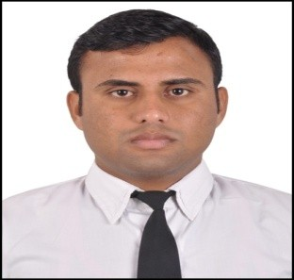
CURRICULUM VITA
ASHWANI KUMAR
Residence: VPO:- Balol, Teh: baroh, Distt: kangra(HP) Current:-+919418664256,9682196833
E-Mail:-ashwanikumarr90@gmail.com

Objective
To secure a respective position which would enable me to utilize my professional experience to the Fullest and challenge my abilities by expanding the horizons while serving the organization.

Educational Details

B.sc In Hotel Management
Batch 2013-2016 3 year Degree
Institute/ University St.soldier institute of Hotel Management & Catering Technology
Extra curriculum ➢ Participation in chef competition activities

Matriculation Education(10th)
Session | 2008
School / Board | Dharamshala Board(HPBOSE)
Senior Secondary School Certificate(12th)
Session | 2010
School / Board | Dharamshala Board(HPBOSE)

Work Experience
- Six Month Industrial Training complete in Hotel NOORMAHAL- 5 star hotel (Karnal, Haryana)
- Job Training complete in Hotel JK Clarks Exotica Dalhousie -3 Star hotel (Himachal Pradesh)
- Working with Aamod Resort Dalhousie as a COMMI -3rd (Indian curry) January 2017 to January 2018.
- Working with Nirvana Hotel Banquets. As a COMMI -3RD ( Indian curry)2018 February to December 2018.
- Working with Bundl Technologies pvt ltd. As a Commi 2nd (Indian Curry) January 2019 to March2020. ( We Opened This Restaurant in Chandigarh)
- Working with Golden tulip Hotel Chandigarh Pnchkula . As a commi 1st (Indian curry) October 2020 to October 2021.
- Working with Fortune Park Dalhousie( Member ITC’s hotel group) As a Commi-1st From October 2021 to June 2022.
- Working with Radisson Hotel Jalandhar.As a Demi Chef De Partie. From July 2022 to January 2023.
- Working with Fortune Park Hoshiarpur. As a Demi Chef De Partie( We have got this hotel opened),From January 2023 to Till date………….

- Hard work
- Confidence
- Versatile
- Dedicate ,loyal, sincere, & positive attitude,
- Punctual
Strengths

Personal Details

Father’s Name Sh. Dharam chand
Mother’s Name Smt. Santosh kumari Marital Status: UnMarried
Languages Known English, Hindi, Punjabi
Date of Birth: 15/3/1990
Nationality: Indian

Business Skills
- Management skills
- Tackling issues
- Social Networking

Philosophy of Life:-

“All Impossible things are possible because impossible word says IM possible”.

I consider myself familiar with professional aspects. I am also confident of my ability to in a team.
Declaration:-
I hereby declare that the above-mentioned information is true and to the best of my knowledge. If given a chance to work in your organization, I would put the best of myself towards the growth of the company

Date:- Place:
(ASHWANI KUMAR)

