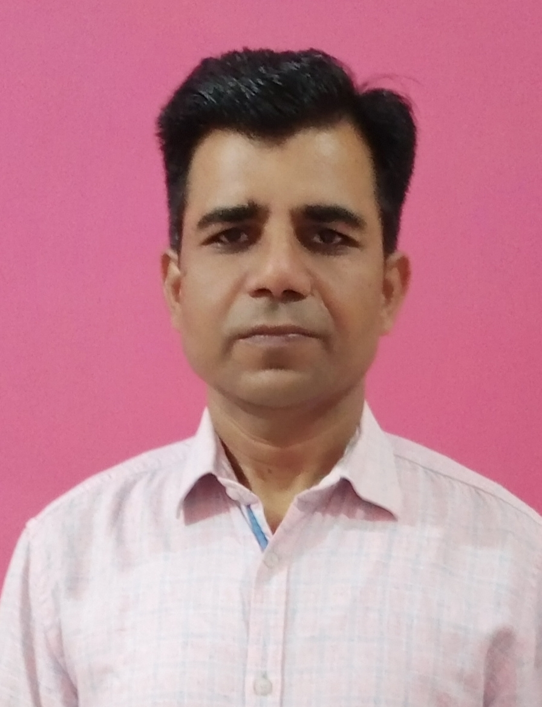
Provide photograph

Neel Kamal Gautam

E-Mail: neelkamal.gautam@gmail.com
Phone: 9521201814 & 8739949315
Permanen Address: H.No. 353/14, Pooran Nagar, P.O. Unnao-209801
Distt. Unnao, Uttar Pradesh

Current Address:- H.NO. C-203, Kesar Altima, Near Zydus School,
Godhavi- 382115, Ahmadabad, Gujarat
Professional Summary:-

“Dedicated professional with almost 21 years of experience in supply chain operations, including store/warehouse management logistics, indirect purchasing, and experience in the automotive, sheet metal, cable, pharmaceutical, rubber, and chemical and tire industries. With a focus on GRN, FIFO, LIFO, self-life, 5S, Kaizen, show moving and fast moving material lists, perpetual inventory, min, max, and reorder inventory levels, among other things. Area safety points; housekeeping; GMP & cGMP; ISO; EHS, OHSAS; proper tagging of all incoming materials; material bin card; material traceability system; and internal or external audits, among other things.”

I Will carry out every day :-

• Inventory/ Stock Analysis in SAP Vs Physical.
• Follow Health, Safety& 5S Compliance.
• Process Improvement.
• Assist to timely Receipt & Issue all Materials.
• Daily basis clearance of all Bills.
• Daily Tagging/Coding of all Materials.
• Accurate and timely MIS & Reports.
• Timely disposing of scrap & hazardous materials.

Organizational Experience

- 11 March 2024 – Present | Deputy Manager – Stores | M/s Rubber King Tyres Pvt. Ltd – Ahmadabad, Gujarat

- 9 April 2015 – 7March 2024 | Deputy Manager – Store| M/s Balkrishna Industries Ltd. Bhiwadi Plant -Rajasthan

- 01 Feb’2011 – 6 April 2015 | Sr. Officer Commercial | M/s Otsuka Chemical & Pharmaceutical(India) Pvt. Ltd., Kotputli - Rajasthan

- 24Aug’2009 – 31Jan’2011| Junior Officer-Store | M/s Wheels India Ltd., Rampur - Uttar Pradesh

- 13 Aug’2003 – 22 Aug’2009|Assistant – Store |M/s FCC Rico Ltd., IMT Manesar- Haryan

Role & Responsibilities of Store :-

- Responsible of managing all incoming engineering and raw material types and carrying out all store operations.
- To be Conscious of appropriate storage, identification, and tag-based traceability.
- To be Conscious of rejection and non-conformance material; send it back to the supplier along with the required paperwork.
- Creating MIS reports on a daily, weekly, and monthly basis, such as those on non-moving things, show-moving items, fast-moving items, scrap-generated data, daily shortage items, and so forth; creating inside and outward reports.
- Keeping track of shelf life inventory reports, performing ABC Inventory analysis, and handling different types wastes and generated scrap
- Monitoring consumption on a daily, weekly, and monthly basis and compiling a list of issues and rejections into Discrepancy Reports
- Preparation of job work Challans for any services/repairs of engineering item, Re-cancelation, inter-branch and other outside.
- To be Ensuring systematic and safe storage of material and that there was no mixing up of any item during storage; implementing proper Material movement System in FIFO.
- Encouraging the application of Kaizen and 5S
- Overseeing standardized Hazardous materials/safety training, as well as periodic training on safety and material handling with MSDS, materials check sheets, and housekeeping protocols to all our team members.
- To be Responsible for 100% accuracy in physical stock. conducting internal or external store audits (5S, EHS, ISO, Quality) and confirming reports on a daily, weekly, monthly, and quarterly basis.
- To be Verify that sufficient manpower is being used for store operations in accordance with established requirements and search for ways to cut back on manpower.

Academic Details:-

- B.Sc. (PCM)- from Kanpur University, Uttar Pradesh in 1999

Personal Details:-

- Date of Birth : 1st May 1979
- Languages : Hindi & English

Neel kamal Gautam

