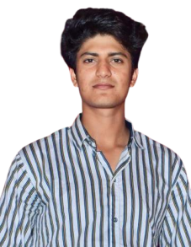


R E S U M E
NAME: MOHD ANAS
E-mail; umair1234rajput@gmail.com
Phone No: 7078061317

CAREER OBJECTIVE :
I am looking for the challenging job where I can utilize my talent and knowledge I want to learn from the organization with growth of organization.


EDUCATIONAL QUALIFICATION

In 2016, High School Passed from (U.P Board)
In 2018, Intermediate Passed from (U.P Board)
Bachelor of pharmacy from Kharvel Subharti College of pharmacy, Subharti University Meerut


EXPERINCE

Fresher


INTERSHIP

Industrial training from ALPS life sciences Pvt. Ltd. sonipat Haryana as a pharmacist

COMPUTER SKILLS

Basic Knowledge of Computer


STRENGTH

Creating ideas
Self Confidence Punctuality
Strong Planning


PERSONAL DETAILS :

Name : MOHD ANAS
Father's Name : ISLAM KHAN
Date of Birth : 16/06/2002
Sex : Male
Nationalist : Indian
Address : Village and Post- Kayasth Baddha Meerut
: Pin Code -250001
Languages : English & Hindi


DECLARE:
I declare that all the information above mentioned is true to the best of my knowledge and believe.

Place:

Date:

(MOHD ANAS)

