Chandra Sekhar Mudragada

CONTACT

chandusekhar199726 @gmail.com+919963122497
2-57 Thatituru.Visakhapatnam District, Andhra Pradesh, 531162, India.

SKILL
Excellent guest service greetings & advising guest teamwork skill good interpersonal skill flexibility time management ability to work effectively under pressure.

INTERESTS
- Listening Music

- Traveling

- Watching Movies

LANGUAGES

- English

- Telugu

- Arabic

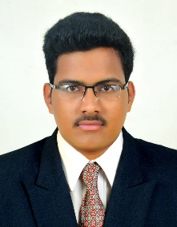

OBJECTIVE

- Strong leadership skills, especially in conflict resolution and personnel motivation. Ability to multitask in a busy and stressful environment.

EXPERIENCE
09/08/2017-17/11/2017 • Radisson Hotel Shimla.

Industrial Training
  - Internship done at Radisson Blu, Visakhapatnam. 3Months in Food and Beverage department like Restaurant and Banquet.

09/12/2019 – 05/01/2024 • The Coffee Address, Saudi

Multi Store Manager
- Handle the Basic Store Operations of 4+ stores (Café + DT)
- Inventory management.
- Dry ordering/Food ordering as per PAR levels for all the stores in the district.
- Aggregator and online business management for the stores.
- Responsible for the Sales, ADT & LFL targets of the stores.
- Maintain SOS and Customer Satisfaction.
- Keep a close track on the Customer feedback at
- Stores/Google reviews/Online social media platforms.
- Ensure proper execution of any new promotions/launches/policy implementation.
- Lead the Coffee House Experience at the stores.
- Hiring/Staff planning/Scheduling of store employees.
- Responsible for Training and development of the store team.
- Lead NSO for the new store openings within the district.
Kno

EDUCATION
2015-2018 • Sun international institute tourism and management Bachelor of Hotel Management ( Passed)
2013-2015 • National Institute of open Schooling (Passed)
2013 • The Sun School 10th (Passed)

