SHIKHA THAKUR 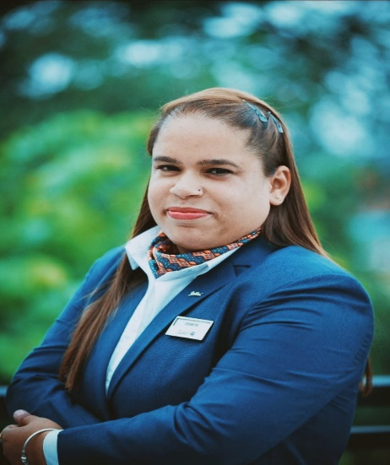
Flat Number 225 Amazon tower
Sunny Enclave Kharar Mohali
Chandigarh 140301
Kanwali seemadwar
Mobile: - 9742324184
Email: Shikha.thakur3012@gmail.com

Professional Objectives

- Seeking a position that will benefit my work experience and job knowledge and help me learn, and develop my skills to a new level.
- Willing to demonstrate my leadership skills in motivating and developing my team and achieving the organizational goal and highest levels of guest satisfactions.

Work Experience

15th August 2023 to till now : Fairfield by Marriott Hotel Amritsar
Hotel (134 rooms)
Designation :Housekeeping Manager (Department Head)

14th March 2022 to 14th August 2023 : Not working due to pragenanacy

01st January 2021 to 13TH March 2022 : Radisson Blu Resort Dharmashala (Preopening
Hotel ( 120 Rooms)
Designation : Housekeeping Manager (Departmen Head )

- Leading the department with new eye as it would be the first resort to work
- Introducing new things to the team to make their work and standard of the hotel upgraded
- Introducing and training the team with new ways of cleaning and checking the room with planned way to make them knowledgeable and skilled
- Coordinating with the Purchase Department & suppliers of housekeeping cleaning agents, guest supplies & equipment’s and maintaining the housekeeping stores.
- Changing the inner and outdoor décor of the rooms to uplift hotel and give new look
- Monitoring the work of Managers, Executives and associates to deliver departmental goal
- Motivating, mentoring, programming and training of unskilled manpower to provide service of the highest standard.
- Daily checking the quality of house-cleaning in guestrooms and public area with particular attention to suites, VIP Guests; supervising as well as ensuring that all services offered by the housekeeping are carried out with utmost efficiency and courtesy.
- Leading the department according to the established concept statement, providing a courteous, professional, efficient and flexible service at all times.
- Ascertaining the availability of stocks for all supplies, inventoried items and making certain that the place of work is adequately equipped.
- Carrying out monthly inventory
- Coordinating with the Purchase Department & suppliers of housekeeping
- Monitoring and controlling consumption of guest & cleaning supplies and devising effective methods for optimal usage of cleaning supplies
- Assist in interviewing, selecting, training, scheduling and counseling staff
- Participation in budgeting and forecasting the departmental expenses.

Work Experience

1st July 2018 to 26th January 2020 till : JW Marriott Bengaluru
281 Rooms
Designation: Assistant Housekeeping manager

1st August 2016 to 31st June 2018 :JW Marriott Bengaluru.
281 Rooms
Designation: Housekeeping executive

Achievements Include

- Got Awarded Manager of the month September 2019 in JW Marriott Hotel Banglore
- Got Awarded Executive of the month of Nov 16 and mar 17 in JW Marriott Hotel Banglore
- Completed MDP (Manager Development program )Marriott International
- Responsible for maintain guest rooms and public area high standards of cleanliness
- Responsible for extra cleaning of floors and façade works
- Responsible for taking care of lost property section
- Taking care of the training part. Has to deal with different companies like diversey, karcher & Unger to come & have a training session. Myself conducting training for team members on LSOP & different housekeeping topics.
- Responsible to taking care Online guest survey(Guest voice) and feedback
- Responsible to taking care of floor fixed asset inventory
- Responsible for deep cleaning and cycle job project for guest room and Public area.
- Responsible for taking care special rooms and service requirement of all guests.
- Responsible for updating all Housekeeping registers and reports
- Monitors Housekeeping personnel to ensure all guests receive prompt and courteous service
- Responsible for complete desk operations i.e. occupancy and discrepancy report, lost & found, Minibar operations.
- To co-ordinate with other department i.e. maintenance for pending complaints , Front office for VIPs arrivals, group movements, F&B departments for any event, Main store for weekly store issue.

Work Experience
01st January 2010 to October 31st 2010 : Optus Sarovar Premiere Gurgaon
80 Rooms
Designation: Housekeeping Associate

Work Experience
November 1st 2010 to 21st January 2012 : The Radisson Blue Suites Gurgaon
32 Rooms
Designation: Housekeeping Supervisor

Work Experience
23rd Jan 2011 to 12 Sept 2012 : The Pride Hotel Gurgaon
94 rooms
Designation: Housekeeping Supervisor

Work Experience

September 17th 2012 to 30th March 2015 : Fortune select Excalibur by ITC group
135 rooms
Designation: Housekeeping Executive
Work Experience

April 02nd 2015 to 20th July 2016 : Crowne Plaza by IHG group
218 rooms
Designation : Housekeeping Executive
;

Educational Qualifications

- Have Completed 3 year degree in Hotel Management from Indarprastha Nehru Academy of Hotel Management Affiliated from All India Council of Management Studies from Dehradun in 2010.
- Have completed intermediate from N.S.M. Inter College, Dehradun (UA Board), in Commerce from Dehradun.
- Have completed High school from N.S.M. Inter College, Dehradun (UA Board), in Commerce Dehradun.

HOBBIES & INTEREST

- Origami Arts, Doing painting, Flower’s Decoration.

INDUSTRIAL TRAINNING

- Have completed six months industrial training in “Life LEISURE” Hotel unit of club nirvana Ludhiana.

PERSONAL DETAILS

Full Name | - Shikha Thakur
Fathers Name | - Sh. Lambardar Singh
DOB | - 30 December 1989
Sex | - Female
Permanent Address | - Lal bahadur shastri nagar kanwali Post office Seemadwar Dehradun(Uttrakhand) India.

LANGUAGES KNOWN:

Language Understand Write Read

English √ √ √
Hindi √ √ √

MY MOTTO: -

To work hard in life and never turn towards the failure. Always hope for the best.

Date:-
Place: - SHIKHA THAKUR

REFERENCES
Sonia Banerjee (Room Division Manager in JW Marriott)
Phone number= +919886909391

