Resume
POST APPLIED FOR FRONT OFFICE OR OPD BILLING, DATA ENTRY

Monika Singh Tomar 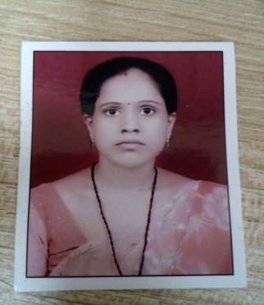
W/O Mr. Jitendra Singh Tomar
Gali No 7, House No. 695
Govind Puri
Kalkaji, New Delhi-110019
Contact #: 9310725995

Career Objective:-
To grow with an organization which will provide me the opportunity for self-development along with the development of the organization, with the desire to learn more? I am confident to achieve the top level in any area of expertise.
Educational Qualification:

Academic Qualification:-
- 10th Passed from MP Board Bhopal in 1998
- 12th Passed from MP Board Bhopal in 2000
- B.A. Passed from Dr. Hari Singh Gaur University, Saugor M.P. in 2004
- M.A. from from Dr. Hari Singh Gaur University, Saugor M.P. in 2008
PROFESSIONAL QUALIFICATION
- B.Ed . Passed from Saugor University, M.P. in 2006
- TET Passed from Allahabad University UP 2012
COMPUTER KNOWLEDGE
- Diploma in computer application
WORKING EXPERIENCE: Fresher
PERSONAL DETAILS
Name: Mrs. Monika Singh Tomar
Date of Birth: August 23, 1982
Sex: Female
Marital Status: Married
Nationality: Indian
Religion: Hindu
Languages Known: Hindi and English
Permanent Address: 7/859
Gali no 7 Govindpuri
Kalkaji
New Delhi 110019
Contact #: 9310725995

