RESUME
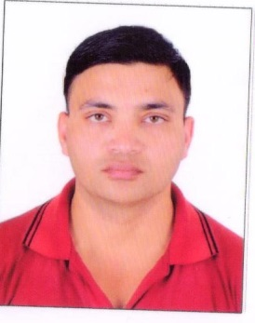

VIJAY K PARMAR
: +91- 8758670350
E-mail:- vraj24340@gmail.com
ADDRESS :-

352 BHATT NAGAR
SAPNA NAGAR
GANDHIDHAM
GUJARAT 370110

CAREER OBJECTIVE:

Seeking A Position To Utilize My Skills And Abilities In Work Environment That Offers Professional Growth While Resourceful While Resourceful And Innovative.

To Be Associated With An Organization Which Provide Me And Opportunity To Grow With It, And An Opportunity To Learn And Contribute To The Goals Of The Organization.

ACADEMIC QUALIFICATION:

- 10th Passed From GUJARAT BOARD
- 12th Passed From GUJARAT BOARD

COMPUTER SKILLS:

- BASIC , INTERNET

WORK EXPERIENCE:

- 9 Year as field supervisor at Patel shipping agency gandhidham.

- 1 Year as field supervisor at Krishna clearing company gandhidham.

- 2 Year as Gym trainer at Fit king ahemdabad.

- 1 Year as Gym trainer at Ironman Gym gandhidham.

- 5 Year as Gym trainer at Holiday village resort gandhidham.

PERSONAL DETAIL:

- Father’s Name:- Mr. Kantilal Parmar
- Date Of Birth:- 05/10/1985
- Sex:- Male
- Nationality:- Indian
- Religion:- Hindu
- Marital Status:- Married
- Language Known:- English Hindi Gujarati

NATURE OF WORK:

- Worked independently and truly with an organization.

DECLARATION:

I here by declare that all the above state information are true and correct to the best of my knowledge and belief.

Date:
Vijay Parmar
Place: Gandhidham (Signature of Applicant)

