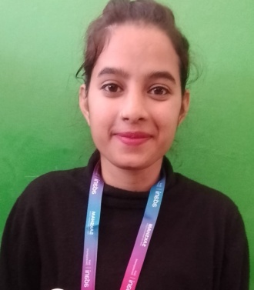

TAMANNA DEVI
Email Id: tamannabhardwaj177@gmail.com
Mobile : 7018397675
Address:Vill. Bahranautan, P/O.Pater, Tehsil.Ghumarvin,Bilaspur(H.P),174026

Objective:
Seeking innovative and challenging career in a growing organization which gives me an opportunity to utilize my skills & knowledge and provides me an opportunity for career growth.

Academic Profile

- Pursuing Food and Beverage Service assistant training from ASDC,Gagal
- 12th from GSSS, Kuthera with 60%
- 10th from HP board with 66%
- BBA From HPU Shimla with 69%

Experience:
- Fresher

Skills:
- Good communication skills
- Quick learner
- Ability to work independently
- Basic knowledge of MS word and excel

Personal Information
- Father’s name : Sh .Rakesh Kumar
- Gender : Female
- Marital Status : Unmarried
- Nationality : Indian
- Languages Known : English and Hindi
- Hobbies : Listening music,Watching TV
- Date Of Birth : 13-09-2000
Declaration: all the above information is correct up to my knowledge and I bear the responsibility of the correctness.

Place: Barmana
Date: 29-11-2023

