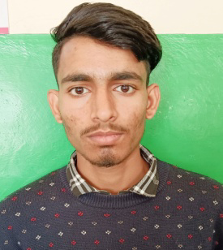
RITESH KUMAR
Email Id: riteshkumar09281@gmail.com
Mobile : 8091530310
Address: VPO.Dhar Tatoh, Tehsil. Sadar, Bilaspur,(H.P), 174001

Objective:
Seeking innovative and challenging career in a growing organization which gives me an opportunity to utilize my skills & knowledge and provides me an opportunity for career growth.

Academic Profile

- Pursuing Food and Beverage Service assistant training from ASDC,Gagal BARMANA
- 12th from G.S.S.S. Dhar Tatoh with 50%
- 10th from HP board with 53.5%

Skills:
- Good communication skills
- Quick learner
- Ability to work independently
- Basic knowledge of MS word and excel

Personal Information
Father’s name : Sh .Ramlal
Gender : Male
Marital Status : Unmarried
Nationality : Indian
Languages Known : English and Hindi
Hobbies : Listening music
Date Of Birth : 27-07-2005

Declaration: all the above information is correct up to my knowledge and I bear the responsibility of the correctness.

Place: Barmana
Date: 29-11-2023

