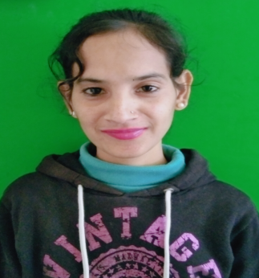

PRIYANKA SHARMA
Email Id: sharmap66349@gmail.com
Mobile : 7876529579
Address: V.P.O. Karloti,Tehsil.Ghumarwin, Bilaspur(H.P) 174029

Objective:
Seeking innovative and challenging career in a growing organization which gives me an opportunity to utilize my skills & knowledge and provides me an opportunity for career growth.

Academic Profile

- Pursuing Food and Beverage Service assistant training from ASDC,Gagal
- 12th from GSSS, Galiyan with 58%
- 10th from HP board with 59%

Skills:
- Good communication skills
- Quick learner
- Ability to work independently
- Basic knowledge of MS word and excel

Personal Information
Father’s name : Sh.Om Prakash
Gender : Female
Marital Status : Unmarried
Nationality : Indian
Languages Known : English and Hindi
Hobbies : Listening music,Singing
Date Of Birth : 27-09-2000
Declaration: all the above information is correct up to my knowledge and I bear the responsibility of the correctness.

Place: Barmana
Date: 29-11-2023

