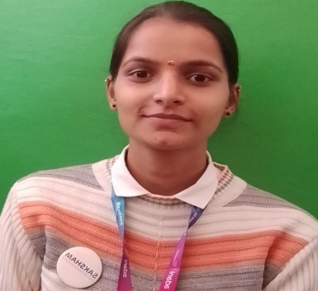

KAVITA THAKUR
Email Id: kavita11720 @gmail.com
Mobile : 8894046772
Address V.P.O.Jamthal,Tehsil. Sadar, Bilaspur(H.P) 174036

Objective:
Seeking innovative and challenging career in a growing organization which gives me an opportunity to utilize my skills & knowledge and provides me an opportunity for career growth.

Academic Profile

- Pursuing Food and Beverage Service assistant training from ASDC,Gagal
- 12th from GSSS, Harnora with 60%
- 10th from HP board with 60%

Skills:
- Good communication skills
- Quick learner
- Ability to work independently
- Basic knowledge of MS word and excel

Personal Information
Father’s name : Sh .Manoj Kumar
Gender : Female
Marital Status : Unmarried
Nationality : Indian
Languages Known : English and Hindi
Hobby : Listening music
Date Of Birth : 06-10-2004

Declaration: all the above information is correct up to my knowledge and I bear the responsibility of the correctness.

Place: Barmana
Date: 29-11-2023

