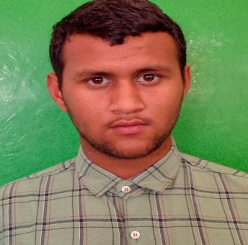

ARUN THAKUR
Email Id: karanthakur35819 @gmail.com
Mobile : 9317935815
Address: VILL. Sanaur,P/O Badi Majherwan,Tehsil.Sadar, Bilaspur(H.P), 174021

Objective:
Seeking innovative and challenging career in a growing organization which gives me an opportunity to utilize my skills & knowledge and provides me an opportunity for career growth.

Academic Profile

- Pursuing Food and Beverage Service assistant training from ASDC,Gagal
- 10th from HP board with 52%

Experience:

Fresher

Skills:
- Good communication skills
- Quick learner
- Ability to work independently
- Basic knowledge of MS word and excel

Personal Information
Father’s name : Sh.Gian Chand
Gender : Male
Marital Status : Unmarried
Nationality : Indian
Languages Known : English and Hindi
Hobbies : Playing handball
Date Of Birth : 19-01-2006
Declaration: all the above information is correct up to my knowledge and I bear the responsibility of the correctness.

Place: Barmana
Date: 29-11-2023

