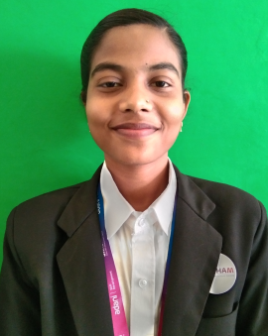

ANJALI KUMARI
Email Id: ak2507702 @gmail.com
Mobile : 9816455915
Address: VPO. Barmana, Tehsil.Sadar, Bilaspur(H.P),174013

Objective:
Seeking innovative and challenging career in a growing organization which gives me an opportunity to utilize my skills & knowledge and provides me an opportunity for career growth.

Academic Profile

- Pursuing Food and Beverage Service assistant training from ASDC,Gagal
- B.com from HP University with 71.1%
- 12th from GSSS Barmana with 74%
- 10th from GSSS Barmana with 69%
Experience:
- Fresher

Skills:
- Good communication skills
- Quick learner
- Ability to work independently
- Basic knowledge of MS word and excel

Personal Information
- Father’s name : Sh. Sunil Chaudhary
- Gender : Female
- Marital Status : Unmarried
- Nationality : Indian
- Languages Known : English and Hindi
- Hobbies : Listening music,Watching TV, Stiching
- Date Of Birth : 14-06-2002
Declaration: all the above information is correct up to my knowledge and I bear the responsibility of the correctness.

Place: Barmana
Date: 05-12-2023

