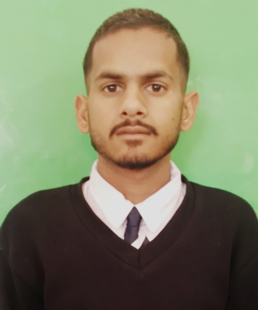

ABHISHEK KUMAR
Email Id: abshiekk879@gmail.com
Mobile : 6230821300
Address: Vill.Chamlog, P/O Deoli, Tehsil.Sadar,Bilaspur(H.P),174001

Objective:
Seeking innovative and challenging career in a growing organization which gives me an opportunity to utilize my skills & knowledge and provides me an opportunity for career growth.

Academic Profile

- Pursuing Food and Beverage Service assistant training from ASDC,Gagal
- 10th from GSSS Panjgain , Bilaspur(H.P) with 52%
Experience:

Fresher

Skills:
- Good communication skills
- Quick learner
- Ability to work independently
- Basic knowledge of MS word and excel

Personal Information
Father’s name : Sh .Kuldeep kumar
Gender : Male
Marital Status : Unmarried
Nationality : Indian
Languages Known : English and Hindi
Hobbies : Listening music,Dancing
Date Of Birth : 06-06-2005

Declaration: all the above information is correct up to my knowledge and I bear the responsibility of the correctness.

Place: Barmana
Date: 29-11-2023

