Curriculum Vitae

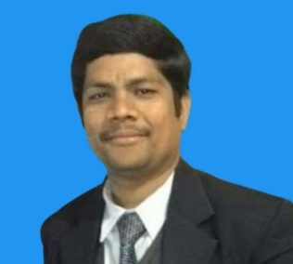
D. RAMESH
Rampur Village,
Dasturabad Post,
Kaddan Mandal,
Khanapur
Adalabad Dist
Pin - 504202

Mobile : 8106963924
Email : positiveattitude96@gmail.com

Career objective
To achieve challenging and a responsible career in an esteemed organization. Where I can share and Enrich my knowledge and skill for the growth of organization as well as individual.

Educational Qualifications
- B.sc(Bzc) from Govt Degree College, Nirmal
- Intermediate from Govt, Junior College, Khanapur.
- S.S.L.C from Govt Z. P. High School, Dasturabad.

Experience
- I have 4 year of work experience in Marketing since 2007 to 2011 in Young India Bnagalore as a Manager.
- Steward and Captain in CROSS ROAD Restaurant in Vijayawada, 2011 to 2016
- PIZZA MAKER AVS hotels in Vijayawada, 2016 to 2017
- BAHAR BIRYANI CAFÉ Restaurant Manager and Cashier in Hyderabad, 2017 to 2022.

Technical Skills
- Basic Computer
- MS Office
- Operating system windows-98, Windows XP, 2000.

    - Key Strengths
- Dedicated to work & talented in understanding job responsibilities
- Proficient learning ability from seniors.
- Highly motivated goal achiever.
- Good communication skills, organizing and managing things.

Hobbies
- Reading Books, Playing Chess Game
- Listening to Music

_{Personal Details:}
Name : D. Ramesh
Father’s Name : Narsaiah
Mother’s Name : Lakshmi
Date of Birth : 10-07-1985
Nationality : Indian.
Religion : Hindu
Gender : Male
Languages Known : English, Hindi, Telugu, Kannada
Marital Status : Married

Declaration:

I hereby declare that the information furnished above is true to the best of my knowledge.

Date :
Place :

(D. Ramesh)

