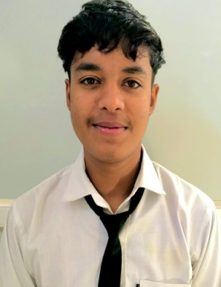
RESUME
Krish haldar
Address- Sakti farm,udhamsinghnagar
Email-krishhaldar324@gmail.com
Phone no – 8449446035

CAREER OBJECTIVE
To get opportunity where can make the best of my potential and contribute to the organization’s growth.
ACADEMIC QUALIFICATION
- Completed 8th From Uttrakhand in 2020
PROFESSIONAL QUALIFICATION
- I have completed diploma in ‘’Hotel Management’’ From
Dev Rishi Educational Society, Dehradun (U.k)
AREA OF INTEREST
- House keeping
TECHNICAL KNOWLEDGE
- Basic knowledge of computer
- M.S Office
PERSONAL DETAILS
- Date of birth : 16/12/2005
- Father’s name : Mr Manoj haldar
- Mother’s name : Mrs Arpana haladar
- Nationality : India
- Marital Status : Unmarried
- Language Known : Hindi, English
DECLARTION:-
Herby I declare that above information finished by me is true and correct to the best of my knowledge.
Date:
Place: (Krish)

