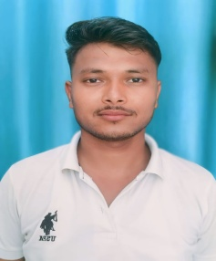
RESUME
Rahul Sagar
Address- Jangal Jogither po- Sarasariya Khatima
Udham Singh Nagar UK 262311
Email-rahulsagar8772@gmail.com
Phone no – 7505422341

CAREER OBJECTIVE
To get opportunity where can make the best of my potential and contribute to the organization’s growth.
ACADEMIC QUALIFICATION
- Completed B.A. Passed In Year 2023 Kumauni University.
- Completed 12th Passed In Year 2020 Form Uk Board
- Completed 10th Passed In Year 2018 Form Uk Board.
PROFESSIONAL QUALIFICATION
- I have completed diploma in ‘’Hotel Management’’ From
Dev Rishi Educational Society, Dehradun (U.k)
AREA OF INTEREST
- House keeping
TECHNICAL KNOWLEDGE
- Basic knowledge of computer & Internet
- M.S Office
PERSONAL DETAILS
- Date of birth : 12/02/2002
- Father’s name : Mr Satydev Parsad
- Mother’s name : Mrs Lalmuni Devi
- Nationality : India
- Marital Status : Unmarried
- Language Known : Hindi, English
DECLARTION:-
Herby I declare that above information finished by me is true and correct to the best of my knowledge.
Date:
Place: (Rahul Sagar)

