NISHA 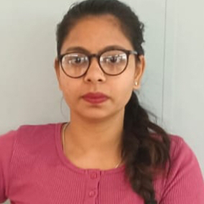
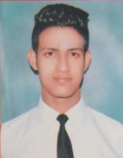
Mobile-No:-6239291615,+97470642006
AVADG NAGAR, KABIR PARK
Amritsar.143002
nv5390923@gmail.com
Passport number:-v1576247
PROFESSIONAL Qualifications:-
>• Bachelor Degree in hotel management and catering
technology(HMCT).

CARRER OBJECTIVE:-CARRER OBJECTIVE:-

To having a good level of job training by using my skills & creative mind, In future I want to start my job to reputed industry in housekeeping .

PROFESSIONAL EXPERIENCE:-

- I have done my vocational training for 2 month in hotel Hyatt regency , Amritsar with a greatful feedback.
- 6 month of industrial training in Taj Chandigarh .
- I have also achieved the appreciation letter for housekeeping department in Taj Chandigarh.
- I have worked in hotel holiday inn Amritsar for last 2 year experience.
- Now I am working as a house keeping associate in InterContinental doha the City hotel, doha.

ACHIEVEMENTS:-

- I am self financing my full college fee by my personal hard work and dedication through various Outdoor Catering Services.
- Have good relations with all the properties and hotel where ever I have worked.

HOBBIES:-
- Listening Music
- Photoshoot
SKILLS:-

- Problem solver
- Co-ordinater
- Self Motivated
- Observation
- Managing People

LANGUAGE KNOWN:-

- English
- Hindi
- Punjabi

PERSONAL INFORMATION :-

- Father’s Name : Sh. Vijay kumar
- Date of Birth : 07,May, 1997
- Marital Status : Single
- Nationality : Indian
- Gender : Female
DECLARATION:-
All the above information is correct and according to the best of my knowledge .
DATE
PLACE SIGNATURE

