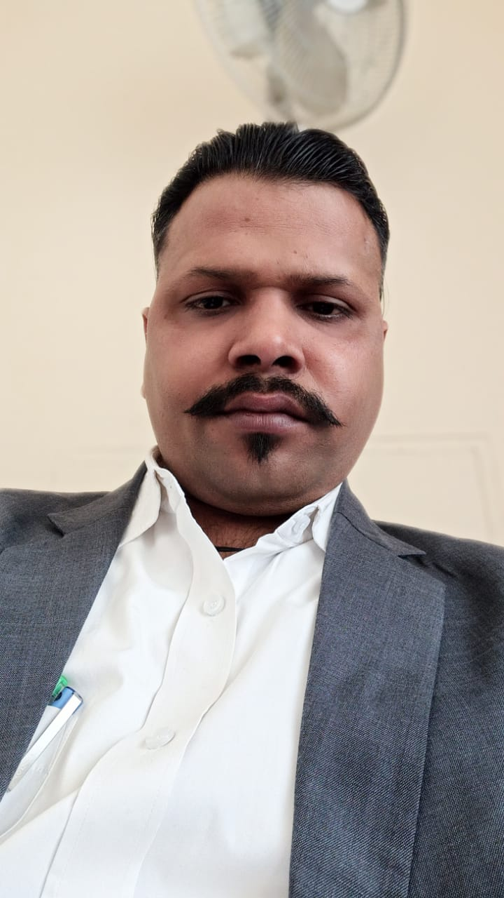
Curriculum –Vitae

PUNEET CHAUDHARY
Address:S/O Braj Mohan Singh Madhuban Vihar
Colony Barola Bypass Aligarh U.P
Mob: (+91)8826212347
Email: puneetgandhar@hotmail.com

Career Objective: Contributing my best to the organization by constant efforts and hard work to meet the organization goal and Guest satisfaction.
Professional Qualification:
- BHM from NIMS Janakpuri Delhi during 2015-17.
- Diploma in Aviation, Hospitality&TravelTourism from Managalaytan University, Aligarh during year 2008-09.
- Red Cross Training
Academic Qualification:
- Intermediate from U.P. Board in year 2007.
- 10th From C.B.S.E. Board in year 2005.
Job Experience:

- Worked as Sr. Executive Housekeeping with Club Mahindra Kumbhalgarh Rajasthan since August 2022 to Dec 2022.
- Worked as Asst.Housekeeping Manager with Abha Grand Hotel (Pre-Opening) Aligarh since June 2021 to July 2022.
- Worked as Asst. Manager Housekeeping with INDIA AWADH Hotel Lucknow since September 2020 to April 2021.
- Worked as Housekeeping Executive with Zone by the Park hotel (Pre-Opening) since April 2018 to July2020.
- Worked as Housekeeping sr.supervisor with Golden Tulip Suites (Pre-Opening) since August 2017 to March 2018.
- Worked as Housekeeping Supervisor with Leisure Inn Hotel West Gurgaon Brand of Stay well Hospitality Since Jan 2016 to Feb 2017.
- Worked as a Housekeeping Supervisor with Vibe By The Lalit Traveller Faridabad since May-2013 to Aug 2015.
- Worked as a Housekeeping Room Attendant with Vibe By The Lalit Traveller Faridabad as a part of (Pre-Opening) team since june-2011 to April 2013.
- Worked as a Housekeeping Room Attendant with Radisson BLU Hotel Paschim Vihar and New Delhi as a part of (Pre-Opening) team since Sept-2010 to April-2011.
        - Worked as a Housekeeping Room Attendant with DLF The City Club, Gurgaon as a part of (Pre-Opening) team from June-2009 to August-2010.
Industrial Exposure:
- Completed six month Industrial Training from Jan 2009 to June 2009 in HOTEL AMAR, Agra.
Hobbies:
- Listening to music and Playing Cricket
TECHNICAL QUALIFICATION
- Basic knowledge of internet,
- Worked on IDS,
- Basic knowledge of M.S Office

STRENGTHS
- Hard Working
- Team player
- Punctual

Personal Information:

Father’s Name : Mr. Braj Mohan Singh
Date of Birth : 06th June1988
Gender : Male
Nationality : Indian
Marital Status : Married
Language Known : Hindi & English
Height : 5.9 inch
Weight : 85 kg

DECLERATION:
I hereby declare that the information furnished above is true to best of my knowledge & belief.

DATE:

PLACE: (PuneetChaudhary)

