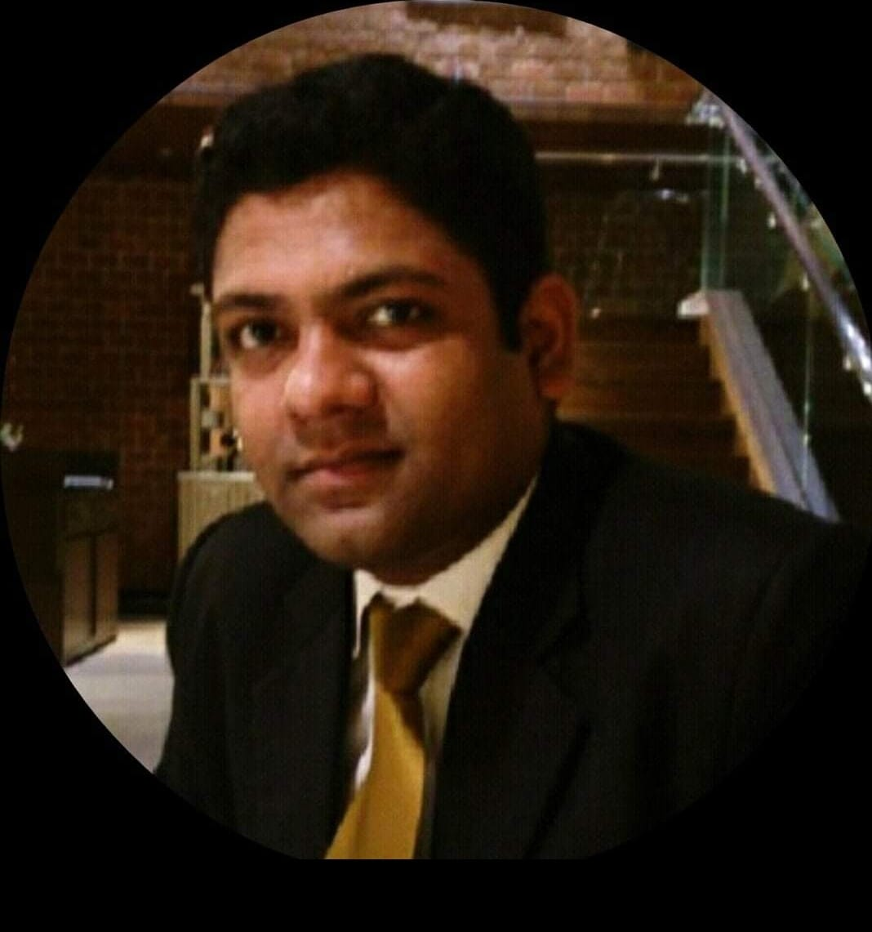

G.Praveen Babu

E-Mail: cananpraveen@gmail.com D/o: 403, Sangam Apartments,
Mobile: +918072877907 Kellys, Chennai – 600009.

Career Objective

Experienced Hotel Management Professional with a demonstrated history of working in the hospitality industry. Skilled in Housekeeping, Guest Recovery, Rooms Division Management, Yield Management &
Property Management Systems. Strong operations professional with a CDT focused in Departmental training from OCLD. Seeking Growth and Challenges in the hierarchy.

Responsibilities

Housekeeping:

- Running Housekeeping operation including rooms, public areas, Laundry.
- Training and developing the team to provide exclusive and totally personalized service to our guests with extremely good consistent guest's feedback.
- Create, review update Standard operating procedure.
- Developed checklist for the Housekeeping workflow
- Monitored the consumption, made monthly analysis and assisted in systemizing and lowering costs
- Worked on MS Office, Fidelio, Opera and Wish net software used widely to run-to-day operations
- Studied the L.H.W. (Leading Hotels of the World) standards of operation, pertaining to Housekeeping.
- Trained new service staff to completely focus on delivering a quality customer experience.
- Monitored and purchased inventory.
- Negotiated agreements with suppliers and vendors that resulted in significant benefits to the company.
- Fostered a team atmosphere through coaching, training, communication, and motivation.
- Developed expertise with computer software including Excel and Daily Housekeeping Report, Planning etc.
- Introduced cost control initiatives, which significantly reduced operating expenses.
- Trained assistant to maintain high standards of cleanliness, safety, and quality.
- Delivered personal attention to customers to ensure high level of satisfaction, to generate repeat clientele, and to encourage word of mouth referrals. Oversaw all aspects of Housekeeping operations including budgeting, cost control, payroll and growth objectives

Skills & Expertise

- Strong sense of motivation for both the team, with well-defined organization skills, I believe strongly in teamwork, and have myself to be decisive, flexible and above all, guest and service oriented
- Customer Relationship Management
- Recruitment and Training
- Staff Rosters
- Financial and Operation Cost Control
- Team Building and Empowerment
- Team Leadership and Motivation
- Time and Workflow Management
- Pars
- Hygiene Standards
- Inventory Management
- Leadership and Delegation
- Opening / Closing Procedures
- Profit and Loss/Budget Accountability
- Planning and Organizing
- Process Improvement / Quality Issues
- Staff Counseling
- Hospitality Management
- Operations Management
- Supplier Negotiations
- VIP Customer Service

Employment History
- 2023 – April 2023 Executive Housekeeper – Cadila Pharmaceuticals, Ahmedabad.
- 2021 – 2022 Executive Housekeeper – Raintree Hotels, CEEBROS Hotels (108 Keys)
- 2020 – 2021 Executive Housekeeper – Rosetta by ferns (220 Keys)
- 2013 – 2020 Executive Housekeeper - ITC Hotels & Resorts (600 Keys)
- 2011 - 2012 | Assistant Executive Housekeeper - Constance Lemuria Resort Praslin, Seychelles (105 Keys)
- 2009 - 2011 | Assistant Housekeeping Manager - The Accord Metropolitan Chennai, India (162 Keys)
- 2008 - 2009 | Assistant Housekeeper - Radisson, Blu, Bahrain, UAE (366 Keys)
- 2007 - 2008 | Housekeeping Executive - Marriott Chennai, India (237 Keys)
- 2003 - 2007 | Housekeeping Supervisor - The Oberoi Amarvilas, Agra, India (105 Keys)

Achievements

- Best Employee of the year 2005
- Champion of the month - Year 2005.
- Recognitions Letters

Academic Qualification
- Three years Diploma in Hotel Management - Canan School of Catering and Hotel Management, Chennai Completed

- Certified Departmental Trainer - Oberoi Center of Learning and Development.

- On the Job Training Skills - Radisson Blu, Rezidor

- Dale Carnegie Training - Constance (Management Skills)

https://www.linkedin.com/in/praveen-babu-813a5010/

Linkedin Profile


Personal Details

Date of Birth : 05.07.1984
Father’s name : Gopi.T
Marital Status : Married
Languages Known : English, Telugu, Tamil & Hindi
Nationality : Indian

Declaration

I hereby declare that the above given information’s are true to the best of my knowledge and belief.

Place: Chennai
Date:

