Yunus navagewale
General Manager Hotel Varsha inn Aurangabad, Maharashtra.

To,
Dear Sir or Ma’am,

Greetings of the day…..!!!

Through some reliable sources and your phone call, I have come to know that Position for General manager lying vacant in you extreme organization, with total of 9+ years of experience. I would like to apply for the same, I am confident in my capacity to become a core element of your organization.

I am well verse with the need of the area of hotel operations and quite happy to be hand on in all departments ensuring of smooth running of the front of the house.

My CV is enclosed and will give you further insight into my capability, qualification and experience in this industry. I look forward to opportunity of an interview to discuss my suitability

Yours sincerely
Yunus Navagewale
+91-6361699362

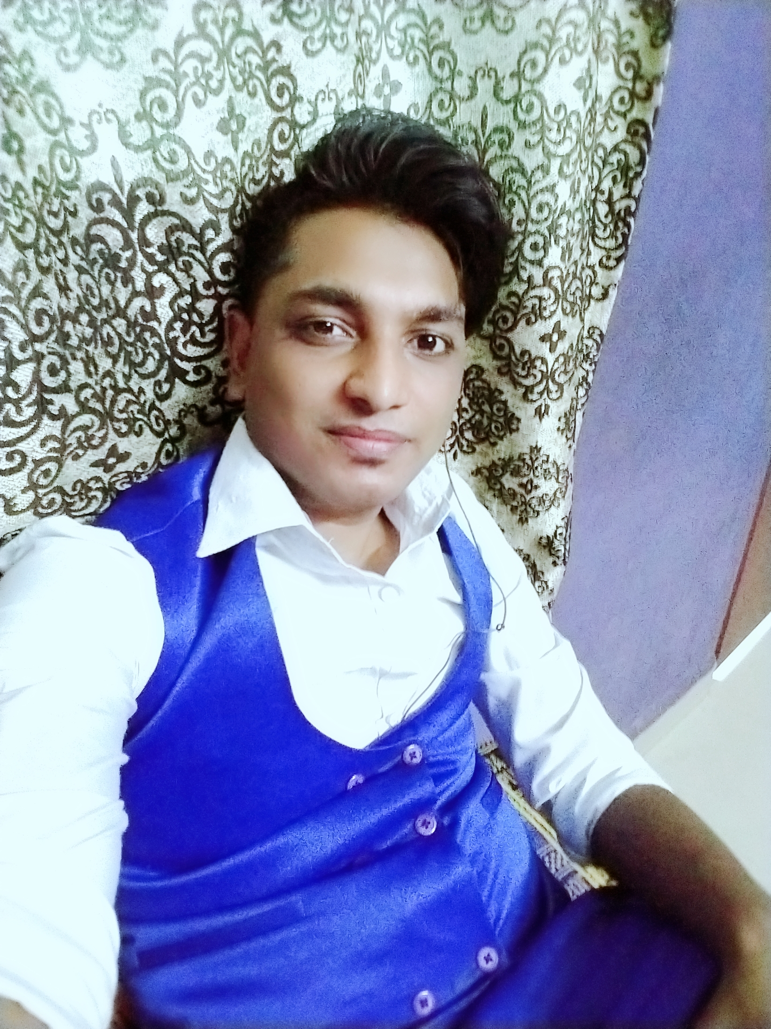
Yunus Navagewale
Hno:237 Mujawar galli,
Peeranwadi, belgaum - 590014
E: ynavagewale@gmail.com
PERSONAL SUMMARY
I am looking for challenging and responsible administrative position in hospitality industry where my professional and academic skills are best utilized in the long run. I am a result oriented food service professional with administrative, operations & management experience in medium sized facilities. I am experienced in supervision, accounting, payroll, employee development, inventory control, public relation & strategic planning. I have excellent inter personal skills, and a team player, have the ability to work on all levels of an organization, troubleshooting & problem solving abilities. I am computer literate, proficient in word processing, spreadsheets, application & use of the internet.
CAREER HISTORY
- Hotel varsha inn, Auranagabad, MAHARASHTRA, INDIA.
General Manager Business Development September 2020 to till Now.

- Responsible for the operational, financial and commercial performance of the hotel.
Duties:-
- Managing a team of Heads of Departments.
- Aligning staff attitudes to corporate objectives.
- Being visible to both guests and staff at all times.
- Doing everything possible to maximize guest satisfaction.
- Increasing all aspects of profitability through revenue generation and productivity, whilst maintaining agreed standards.
- Setting consistent standards of service across all areas of the hotel.
- In charge of the safety and welfare of customers, workers and members of the public.
- Overseeing the hotel operation on a day to day basis.
- Dealing with escalated guest complaints.
- Deliver an excellent Guest and Member experience to all those who visit the hotel.
- Continually developing all aspects of the Hotels Operations such as the front office, reception, reservations, and revenue, F & B and housekeeping departments.
- Working closely with hotel directors to put together long term business plans.

Work experience :
* Worked a front office associate “ Casino hotels Ltd  T.B Road,Thrissur,Kerala for one years.

* Worked as front office associate at Hotel Colva Kinara Near ColvaBeachGoa for two year.

* Worked as front office supervisor at “Casa Rio ” Atthirappily, Kerala for two years.

* Worked front office executive at “options lawns ” Bheadaghat,jabalpur,madhya pradesh for 6 Month.

* Worked front office Manager at “options lawns ” Bheadaghat,jabalpur,madhya pradesh for 1 year.

* Worked as a General manager at "varsha inn" Aurangabad, Maharashtra for till now

KEY SKILLS AND COMPETENCIES
Professional
- Can quickly put guests at ease with casual banter.
- Understanding the needs of a discerning customer.
- Menu layout, menu approval and buffet presentation.
- Providing visible leadership by example while interacting with guests.
- Well versed with Property management system (PMS) IDS, Inffinit, hotsoft, opera.
- C- programming.
- Tally ERP9. P
- Ms office, Ms excel, Ms Power Point.

Personal
- Willing to jump roles and take charge of other departments.
- Hard working and never going home until an important job has been completely done.
- Can operate effectively in a highly varied and hands on role.
- Enjoys mentoring and developing a young team.
- Excellent English skills in both writing and speech.
- Self learner
- Learn from sarounding and fast dicittion maker.
- Work under pressure.
- A good team player.
- Play key role to customer complaints.
AREAS OF EXPERTISE
- Hotel sales
- Marketing
- Managing budgets
- Controlling expenditure
- Hospitality industry
- Customer service
- Solving problems
- Guest satisfaction
ACADEMIC QUALIFICATIONS
- Aptech Aviation and hospitality academy DHM in the year of 2012-2013
- Islamiya pre University . Collage Karnataka. H.S.C. In the year of 2011-2013
- Beynonsmith H.S. School Karnataka. S.S.S. In the year of 2010-2011
REFERENCES
- Mr. Rohith Patill (Director Hotel varsha inn)--+91-9823467937
- Mr. Rajneesh verma (Director of Option lawns and convection.)--+91-9425159410
- Mr. SHAJU THOMUS (M. D. Casa Rio resort)--+91-8086070000

Personal Details:-
- Date of Birth : 20th,February, 1995.
- Father’s Name : Mr. Ibrahim M Navagewale
- Permanent Address : Mujawar Galli, Peeranwadi.
Belgaum-590014

- Languages Known : English, Hindi, Kannada & Marathi
- Hobbies : Listening to music, reading Indian literature

Date:-
Place:-
YUNUS NAVAGEWALE

