SUJIT KUMAR MISHRA

About Me

+919983495572/9488354364
19 Years experience

linkedin.com/in/sujit-mishra-b8b08837/
Sujit2man@gmail.com

March 21, 1975
Ajmer , Rajasthan,India
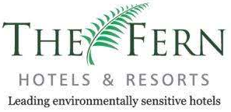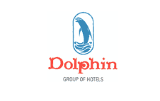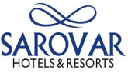

General Manager –Hospitality and Sales Professional
A positive contributor in pursuit of excellence, sustainable ,patient and receptive to the needs of everyone ,open to new ideas to achieve excellence in life by associating with an organization ,where I can apply my knowledge and skills to contribute towards organization’s growth as well as personal growth .
Abridgement
An enthusiastic individual with energy, drive with passion to create excellence and exceed expectations with Over 19 Year’s experience.

I like to influence change and make a visible difference within an organization. I have always been keen on innovation, providing stability and an efficient interface with guests to achieve a high level of mutual satisfaction. My emphasis is always on discipline, planning, organizing, training and team building with high motivational levels to produce the best results keeping in mind the company’s values. A consultative management style and exceptional people skills. My career includes senior executive positions, including an General Manager’s role in my current hotel position where I have assumed responsibility for implementing triple bottom line operational frameworks which provide for sustainable growth well into the future, including positive financial results, a competitive market position and value proposition, and a balance interaction with the environment and the local communities.

Skills

OPERATION MANAGEMENT  Pre-opening  Resort Management  Food & Beverage Operations  Multi –site Operations  Hospitality Management | STAFF MANAGEMENT  Recruiting/Hiring  Talent Optimization  Training & Coaching  Motivation Empowerment | CUSTOMER SERVICE  Guest Satisfaction  Increased Occupancy  Customer Retention  Quality Assurance | P&L MANAGEMENT  Budget Management  Cost Control (Labour, F&B )  Asset Management  Strategic Planning


Work Experience

CURRENT EMPLOYER:
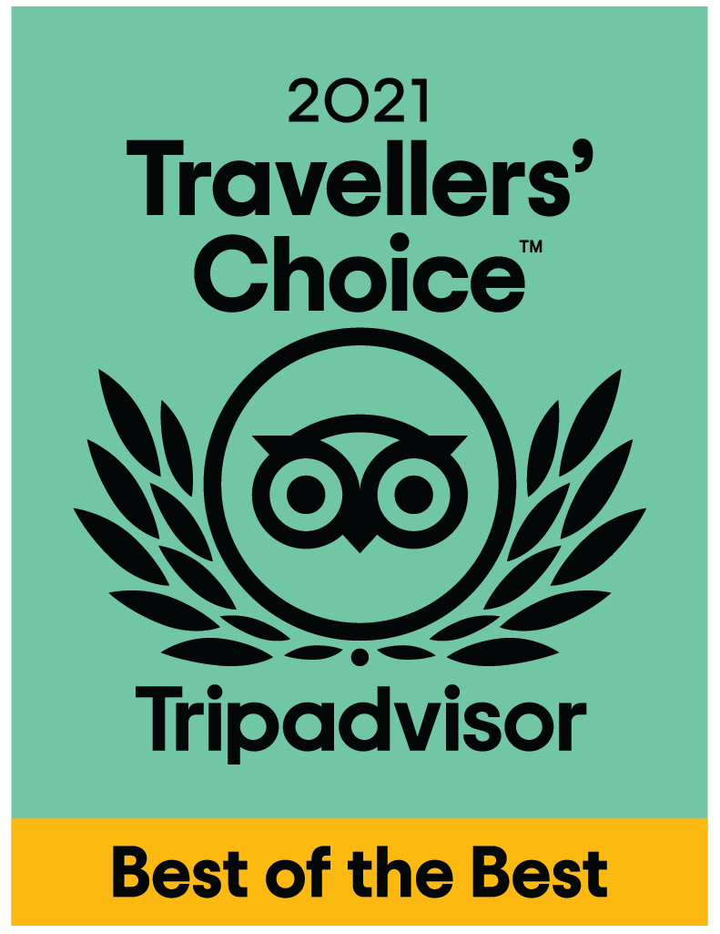

The Royal Melange Beacon, Ajmer
Rajasthan
Concept Hospitality Pvt. Ltd.
Current Position: General Manager-Operations
Since June 2016 –till date

Hospitality Operations & Catering Management:

- People Management and Development
- We got Travelers’ Choice 2021 certificate from Booking.com
- We got Travelers’ Choice 2021 certificate from Tripadvisor
- We got HALL of fame certificate from Tripadvisor
- Client Management & Relationship Building
- Business Development
- Strategic Partnerships and Alliances

JOB RESPONSIBILITIES:

• Ensure highest level of customer satisfaction by providing quality customer services and amenities within corporate standards.
• Monitor the present and future trends, practices and systems in the Hospitality industry, determine and ensure execution of competitive programs.
• Participate actively in selling the Hotel services through involvement with all potential market clients.
• Lead cross functional team of 95 to managed operations of the 24 keys+32 Keys hotel’s enhancing trip advisor rating from a laggard 9 to No 1 in Ajmer and awarded with Certificate of excellence.
• Brought about professional approach by putting in place robust operational structure enhancing quality of service deliverables registering Compound Annual Growth Rate of 36%
• Directed and trained on service etiquette, soft skills, menu and hotel knowledge for guest service excellence consistently garnering positive on-line reviews
• Identified need to enhance user experience, look and feel, upgraded website and micro-sites on global portals like Makemytrip.com, Expedia.com et al
• Coordinated with promoters and all division heads to strategize annual budget plan based on past performance achieving 80% occupancy levels
• Focused on local marketing activities in local print, television and radio for food festivals and other promotional activities bringing in revenue footfalls
• Formulated departmental SOP ensuring implementation consistently reviewing daily and monthly reports to ensure GOP margins at above 38%

Previous employer

Company | Club Mahindra Mashobra ,HP
Company Profile | 67 Key with Two Restaurant and multiple F&B outlets
Designation | Manager-Food & Beverage
Tenure | 2014 –2016
Job Responsibility | Overlooking the F&B Operational Process Implementation for F&B Department  Ensuring control of expenditure within budget  Up Dating Guest Holiday feedback  Budgeting-Forecasting –Analysis F&B demand; People Management skills  Yield and Revenue Management and P&M and Capex budget management for F&B .

Company | Fern Hill , Ooty, Tamil Nadu
Company Profile | 200 Key with Ooty biggest conference hall and multiple F&B outlets
Designation | Food and Beverage Manager
Tenure | 2011 –2014
Job Responsibility | Overlooking the F&B renovation and Operational Process Implementation for F&B Department  Ensuring control of expenditure within budget

Company | Hotel Tara, Ramoji Film City, Hyderabad ,AP
Company Profile | 186 Key Five Star Hotel
Designation | Asst. Food and Beverage Manager
Tenure | 2009 –2011
Job Responsibility | To develop strategic plans for the Food and Beverage Department.  Recruit, develop and manage the Food and Beverage Department team to Ensure a proactive, positive culture of staff relations.  , 2 resta 186 key with 2Restaurants, 1 club and 2 conference Hall.

Company | Fortune Select Manohar , Hyderabad ,AP
Company Profile | 132Key Five Star Hotel
Designation | Food and Beverage Executive (Received award for Best Employee of the Hotel for May 2009 & Star of the Month for May 2009 F&B Service By Area General Manager )
Tenure | 2007 –2009
Job Responsibility | A 132 room property. Fully responsible for all day to day Banquet operations of Food and Beverage Service which included a Three Banquets

Company | Club Mahindra Kodagu Valley, Coorg, Karnataka
Company Profile | 122 Key Five Star Hotel
Designation | Food & Beverage Executive
Working Duration | 2005 to 2007

Company | Aditya Park Inn, Hyderabad,AP
Company Profile | 88 Key Three Star Hotel
Designation | Senior Captain (Received award for 'Train the trainer ‘ From Sarovar Park Plaza. )
Working Duration | 2004 To 2005

Company | Amrutha Castle, Hyderabad, AP
Company Profile | 90 Key Three Star Hotel
Designation | Senior Captain(Received Appreciation letter from RM for Excellent Service )
Working Duration | 2003 To 2004

Company | Swosti Plaza,Bhubaneswar,Orissa.
Company Profile | 156 Key Three Star Hotel
Designation | Captain
Working Duration | 2001 To 2003

Company | The Pride Hotel ,Nagpur
Company Profile | 100 Key Five Star Hotel
Designation | Industrial Trainee
Working Duration | 2000 To 2001

Education

 Diploma in Hotel Management
IIHMCTN Bhubaneswar, Orissa (1999-2002)
Computer Proficiency

Word 2010 , Excel 2010 ,Power Point 2010
Languages

Hindi & English

Personal Details

Place of Birth : Dhanbad ,India
Nationality : Indian
Family Status : Married
Hobbies : Fight against Global Warming
Save the Children

