.
Sasipal singh
9516552022 m

Address
Village okra, Post okhra, Okhra, Firozabad.
Personal Details
D.O.B=1/1/1995
Marital Status:Single
Email: - sashipal54@gmail.com
Mobile:6261182790

CAREER OBJECTIVES-

Looking for challenging position in a professional & dynamic organization that promises bright growth prospects & opportunity, which can help me in developing my career.

WORK EXPERIENCE:

Work experience in Gujarat Ramesh in mithai 1 year..

Nagpur haldiram 3 year experience.
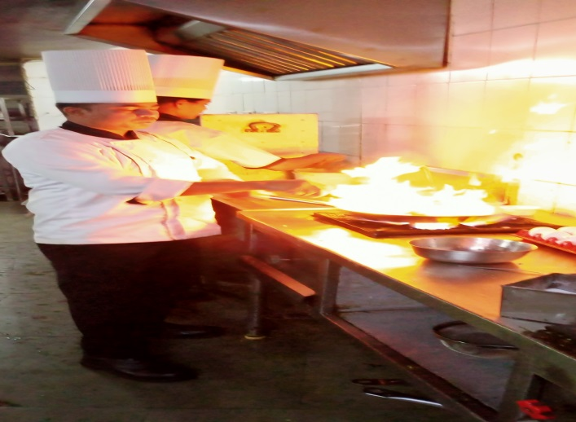
Hotel celebrations Raipur 2 year experience.

Hotel leeleak 1.5 year experience.

Hotel Taj Gateway, Raipur Chhattisgarh pin code 492006

Joining date 15/01 2016 February
Last date 02/10/ 2017

.Hotel sayaji Raipur Chhattisgarh GE ROad Behind magneto Mall

Joining date 01/8/2017
Last date 01/09/2018

Hotel Marriott resort and spa in jaisalmer, Rajasthan
joining date 27 August 2018
Last date 27 January 1019

. hotel celebration Raipur Chhattisgarh pin code 492009 CDP

Joining date 10./11/2020
Last date 09./09/2022

Working in hotel Radisson Blu Visakhapatnam Andhra Pradesh Vizag September joining date 16 /9/22 Sr CDP

FATHERS NAME-Mr. Shri ram

MOTHERS NAME- Mrs. Tulsa devi

HOBBIES: Playing Cricket, Listening

LANGUAGES- Hindi.

