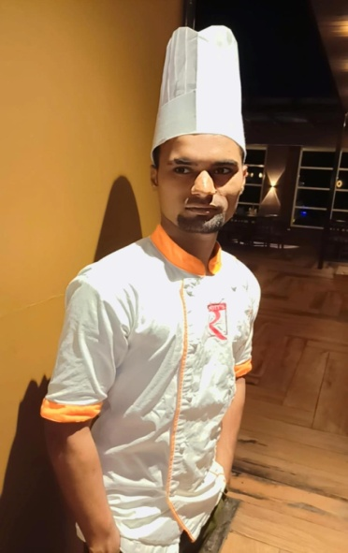

SANDEEP KUMAR MALVIYA
RESUME

ADD:- Ward No.1 Durga Nagar Post Gulabganj, Gulabganj Vidisha MP. 464220.
Contact No - 9630615520
Email – sandeepkumarmalviya820@gmail,com

CAREER OBJECTIVE.
To work with an organization that can give me persistent growth in career and can give me recognition as well , where my skills can be utilize to its potential allowing me to attain professional and personal development.

QUALIFICATION
- BA. Passed from Barkatullah University in the year 2023.

WORK EXPERIENCE

- Currently working at Hotel Ranjit Legacy in Bhopal as a 1st coming chinese,
- Worked as a Chinese Cook in Hotel Sayaji Bhopal from 2020 to 2021.
- Worked as a Chinese Cook in Hotel Relish Restaurant from 2018 to 2019.
- Worked as a Chinese Cook in Hotel Grand Nagarjuna from 2016 to 2017.
- Worked at Hotel Central in Guntur as AS 1st coming cheff chinese from Dec 2013 to 2014.

PERSONAL INFORMATION

Father Name : Mr. Rajaram Malviya
Date of Birth : 23/07/2002
Gender : Male
Marital Status : Unmarried Languages known : Hindi ,English Nationality : Indian

DECELERATION:

I have declare that above information is true to the best knowledge and belief. DATE …………….. ( Sandeep K Malviya )

