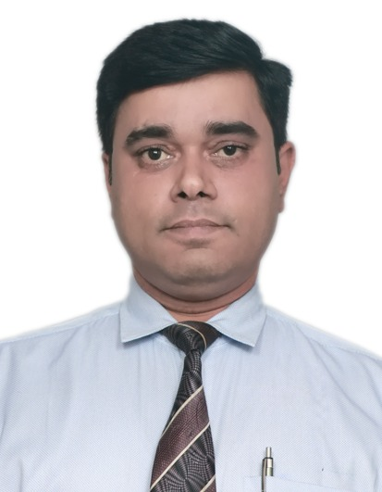
MANISH KUMAR
E – 16, Krishna Park
Khanpur
New Delhi -110062
Ph : +91 9810250097
Email : manish2661@hotmail.com
Skype ID: manish2661@hotmail.com

PROFESSIONAL SUMMARY

Dedicated General Manager with more than 15 years of experience in hotel industry providing clients with the highest degree of hospitality and customer service by ensuring that facilities meet and exceed expectations. Strong leader possessing outstanding work ethic and integrity, always dedicated to meeting budget and meticulously documenting financials. Manages by leading and showing staff the rewards of pushing past their own expectations to provide the best work possible.

PROFESSIONAL QUALIFICATION

B.Sc. in Hospitality & Hotel Administration from Institute of Hotel Management, Catering & Nutrition, Pusa, New Delhi.

EDUCATIONAL QUALIFICATION

- Passed Class 12th (C.B.S.E.) from Cambridge School, Tatisilwai, Ranchi in the year 2001.
- Passed Class 10th (C.B.S.E.) from Sainik School, Purulia, West Bengal, in the year 1999.

ACHIEVEMENTS

- Managed to achieve NOP of 31% from hotels in my portfolio at Oravel Stays.
- Managed to achieve Guest Satisfaction Performance(NPS) of 4% from hotels in my portfolio performing earlier at 36%.
- Managed to increase F&B and other ancillary revenues by 40% and achieved highest offline revenues among all hotels in Delhi by OYO.
- Received an email of appreciation from the Founder and top level management for achieving ‘A’ rating in my OKR in 1st quarter of 2018.
- Achieved 3 star classification for juSTa Panjim(Also known as Mystique Heights) from Ministry of Tourism, Govt. of India in 2015.
- Setting up of Companys Operations & expansion in Goa with juSTa Hotels & Resorts.
- Managed to achieve and maintain Rank 1 position of juSTa Panjim in Panjim, Goa as well as maintained the ranking of both hotels in Delhi among Top 20 hotels in the region.
- An active member of pre opening team of Rock Manali. Streamlined & established the SOPs to ensure World Class Experience to our guests.
- Managed to achieve the break even for Velvet Apple Hotel with 1 year of operations.
- Streamlined and standardized the operations at the newly opened boutique hotel, Velvet Apple in Delhi.

WORK EXPERIENCE

Working as General Manager with Versatile Hotels Pvt Ltd. since July '20.

Worked as General Manager with Niraamaya Retreats Pvt. Ltd. from Aug 19 till Feb '20.

- Management of all aspects of the Wellness Retreats. Assisting in the execution of the HODs overall strategy for the property while also highlighting issues as they may arise and formulating solutions in line with companys vision and policies.
- Daily briefing with HODs to ensure each divisions sales and revenue targets are tenable, standard operating procedures are continuously met in order that routine operations are smoothly carried out and guests feedback is reviewed and appropriately actioned.
- Ensuring every guests enjoy a perfect stay and all curated experiences are carried out as per SOPs.
- Monitoring supplies, inventory and purchasing on daily basis.
- Monitoring overhead expenditures, incident reports as well as department requests, purchase reports and accounts payable and accounts receivable.
- Maintaining relationship with the suppliers and vendors to assess the quality of goods and services purchased and also for performance assessment purposes.
- Evaluating staffing needs at any given time, to hiring, training and planning staff development, Coordinating with both the hotels HR department, as well as each department head, to determine their specific staffing requirements.
- Daily coordination with sales and marketing team and monitoring conversion rates, the efficacy of all distribution channels and pricing.
- Assisting VP Operations in formulating the annual budget and monthly forecasts.
- Ensuring the property meets all legal requirements and conforms to local codes and established regulations at all times.

Worked as General Manager with BMK Hospitality Pvt. Ltd., New Delhi from Nov ’18 till Aug ’19.

Worked with Oravel Stays Pvt. Ltd. as General Manager for Flagship and Townhouse brands from Nov ’17 till Oct ’18.

Worked as General Manager Operations with juSTa Hotels & Resorts from Nov ’11 till Nov ’17 and handled operations across cities (Delhi, Goa).

Worked as Manager - Operations with the Velvet Apple Hotels, New Delhi from April ’09 till Oct ’11.

Worked as the Assistant Operation Manager with the USHA LEXUS GROUP of Hotels & Resorts from June ’07 to March ’09 at Varca Le Palms Beach Resort Goa.

Worked as Management Trainee with the USHA LEXUS GROUP of Hotels & Resorts from June ’06 to May ’07 at Varca Le Palms Beach Resort Goa.

Completed 6 Months Industrial Training Module with Jaypee Siddharth, New Delhi from May ’04 to Oct ’04.

PERSONAL MEMORANDA

Fathers Name : Late Mr. Hardeo Singh
Mothers Name : Mrs. Shakuntala Devi
Date of Birth : 15th July 1982
Strengths : Strong will power, determination and hard working nature
Marital Status : Married
Nationality : Indian

