RESUME
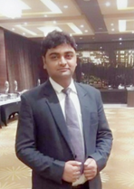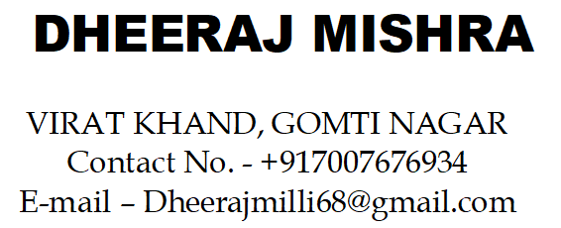
OBJECTIVE:-
Experience General manager with a Demonstrated history of working in india. Skilled in Pre-opening, Food and beverage Operstions, Micro/IDS/ Logix/EzeeTechnologies, with highly motivated person. I enjoy working with the SOP’s .looking for long term employment in a friendly environment.

PROFESSIONAL EXPERIENCE
- One earth Group of Hotels, Amritsar ( May'21 –Till Now)
General Manager
Hotel One earth Avaas :- Has 30 room with Two Banquet hall capacity of 200 pax each
with one roof top restataurant, Restobar, and Cafe

- Troop Hunters & Hospitality, Meerut (sep'18 -Apr 21)
General Manager
Hotel has 27room, Three7500sqft hall, One 4500sqft hall, One2200sqft hall, One Restaurant 60 cover Multi cuision restaurant, one Bar 80 cover with all imported and domestic alcohol, and one conference room

- Tewani & Amarnani Infra Pvt.Ltd, Lucknow (Apr'17-sep 18)
Unit Head
Hotel Has 42 room, One 11000sqft lawn, One 4500sqft hall, One 2200sqft hall, One Restaurant 60 cover Multicuision Restaurant

- Brijwasi group of hotels, Mathura (April 2013 –Mar 2017)
Food &Beverage Manager
Hotel Has 33 room, One 20000sqft lawn, One 6500sqft hall, One 5000sqft hall, One Conference hall, 60 cover Multicuision Restaurant And Bar 60 Cover

- Hotel Lilly White, Delhi(July 2012- march 2013)
Asst.Fnb Manager
Hotel Has 30 room, Two 10000sqft lawn, Two 5000sqft hall, One 1500sqft hall, One Restaurant 30 cover

- Marg group of Hotels, Agra(Jan 2010-June 2012)
Restaurant Manager
Hotel Has 52 room, One 4500sqft hall, One 2200sqft hall, One Restaurant 60 cover

- SbarroRestaurant (Oct 2008- Dec 2010)
Shift Manager
It has a 48 cover restaurant and take away and Delivery also.

- Joined Pizza Hut (a Unit of RJ crop) Agra as a Team Member in April 2006 and promoted as a Buddy Trainer in Aug. 2006. Promoted as a Buddy Trainer Of cash in April 2007.Promoted As a R1 Candidate (Trainee shift Manager) in April 2008.

- Complete 3 year of Traning from ITDC Ashoka Agra in F&B.(Nov 2003-March 2006)

ROLES & RESPONSIBILITY
- Design strategies to ensure total guest satisfaction.
- Develop an annual business plan.
- Ensure highest standards of professional services to customers.
- Initiate Cost effective controls and revenue management techniques.
- Prepare, review and assess monthly or periodic financial statements.
- Create brand image for the hotel.
- Develop strategies for organizing, staffing, planning and executing functionalities.
- Provide training for hotel staff in delivering care that meets the best standards and practices.
- Develop day-to-day operations and functions of a hotel ensuring total guest satisfaction.
- Maintain and manage hotel equipment, infrastructure, inventories and other facilities efficiently.
- Planned work schedule for various indiviusal, team and department working in the hotel
- Hold regular briefings and meetings with all Department HOD’s Staff.
- Ensure full compliance to Hotel operating controls, SOP’s, policies, procedures and service standards.
- Ensure that monthly financial outlooks for Rooms,Food& Beverage, Admin & General, on target and accurate.

EDUCATION
High School with C.B.S.E. board, AGRA in year 2000
Intermediate with C.B.S.E. board, AGRA in Year 2002
B.Sc in math’s with Dr. B.R.A. UNIVERSITY, AGRA in Year 2007

ACHIEVEMENT
2007 Area coach award Q1
100% Customer satisfaction award
Best employee of the month

IT SKILLS
Worked on Multiple Software
- IDS Gennie
- Hotel logix
- Ezee Technologies
- Opera

INTEREST
- Love to cook food for my family
- Listen Music like Ghazals

PERSONAL DETAILS
Fathers name Shri K.K. Mishra
Mothers name Smt. Tara Mishra
Sex Male
D.O.B 25 -09-85
Marital status Married
Religion Hindu
Nationality Indian
Language Hindi, English
Strength Positive attitude

I, DheerajMishra hereby declare that the above information is true to the best of my knowledge.

Date:

Place: (DHEERAJ MISHRA)

