CURRICULUM VITAE
ANJAN MUKHERJEE 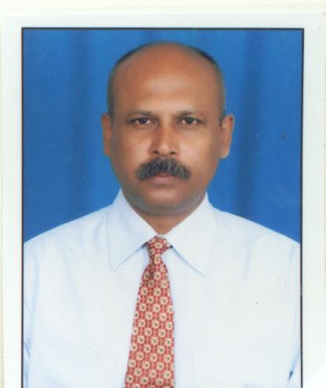
CAREER GOAL
Seeking a position to utilize my skills and abilities in the Industry that
offers Professional growth while being resourceful, innovative and
flexible.
ACADEMIC QUALIFICATION
I.C.S.E., I.Com.
PROFESSIONAL SKILLS
Ø 3 years Diploma in Hotel Management, Catering & Applied
Nutrition.(Patna Catering College) 1986-1989.
PRACTICAL TRAINING
Ø Taj Savoy – Ooty – 1 Month
Ø Taj Fort Aguada Beach Resort – Goa 1 ½ Month
Ø Hotel Oberoi Palace – Srinagar – 3 Months
Ø Hotel Chanakya – Patna – 3 years (Adhock Basis )
EMPLOYMENT RESUME
Ø Hotel Dukes Retreat – Khandala – 3 years as Senior Captain (10/2/1990 – 31/3/1993)
Started my career as senior captain in the hotel Dukes Retreat was responsible for overall
day to day functioning of restaurarant and room service.
Ø Hotel Polo Towers – Shillong – 2 years as Restaurant Manager (01/5/1993-15/6/1995)
Was responsible for day to day operation of the restrant.job responsibility was interact the
guest,cordinate with the kitchen regarding the menu of restaurant buffet . To increase the sale
the sale of restaurant and to ensure that the operation runs smoothly.
Ø Hotel Orange City – Nagpur- 3 years 4 Months as Restaurant Manager(04/10/1995- 08/2/1999)
Was responsible for guest relation of the restaurant to make the duty roaster of the staff, to ensure
proper and prompt service to the guest. The restaurant was of 92 covers.
Ø Hotel Tulli International – Nagpur – 3 Years 4 Months as Coffee ShopIncharge (01/3/1999 –10/8/2002)
The coffee shop four seasons was of 120 covers was mainly responsible to coordinate with the kitchen
and plan cyclic menu with the kitchen for buffet, breakfast and buffet lunch and dinner. To coordinate
with the kitchen and the F&B manage to plan and implement menu for food festival.
Ø Hotel Babylon International – Raipur – 8 ½ Months as F&B Executive(14/8/2002- 30/4/2003)
It was my first pre opening property. Was a proud recipient of letter of congratulation for giving
the highest ever sale of the restaurant ever since opening of the hotel from the Executive Director.
My other responsibilities was staff planning, menu planning for the restaurant buffet lunch and dinner.
Under my leadership we had hosted to food festival.
Ø Hotel Celebration – Raipur – 01 years 10 months as Asst. F&B Manager(01/6/2003- 28/3/2005)
It is the hotel of 58 rooms 1 multi cuisine of 97 cover, 1 coffee shop of 26 covers, 5 banquet hall
One discotheque one area for pool side party. My main responsibilities were banquet booking, 2
coordinate with the Executive chief regarding banquet menus. My other responsibilities were to
achieve the target given by the management and to do the budgeting and forecasting.

Ø Hans Hotel - Hubli as F&B Manager. (05/04/2006 – 15/04/2007)
Ø Hotel Jaybee Inn - Bilaspur as General Manager. (01/05/2007 – 31/05/2013) (Pre-opening property)
It was my first pre opening property as General Manager. It is the first boutique hotel in Bilaspur
comprising of 34 rooms, to banquet’s, 1 restaurant of 92 covers, 1 coffee shop of 36 covers. My
main responsibilities was to run the property with the highest standard regarding the quality of
service and food. I had achieved the sales target after tying up with corporate houses and government
establishment. In and around Bilashpur. I was the sole responsible person in terms of revenue generation

Ø Hotel Emerald - Bilaspur as General Manager (05.06.2013 – 31.10.2015) (Pre-opening property)

Ø Hotel Solitaire - Raipur – as General Manager ( 16.11.2015 – 16.03.2017 ) (Pre-opening property)
It is one of the finest hotel in hear of Raipur. I was solely responsible for staff recruitment from the
Preopening stage, it is hotel of 48 rooms, 3 banquet halls,1 multi cuisine restaurant of 60 covers, 1bar
of 79 covers, 1 coffee shop of 32 covers. My main responsibility was to do the sales and marketing of
the hotel with various corporate houses with my period. I am proud to say that I have achieved the given
target set by the management. Utmost importance was given to set of the highest level of S.O.P. and I used
to make sure that it was followed.

Ø Mittal Group of Hotels - Ujjain – as General Manager ( 01.04.2017 to till date)
(90 keys Hotel with Two Wedding Lawns and Four Banquets One Restaurant of 80 Covers, One Bar Cum Pub)
It is the property of 2 hotels one of 46 rooms and 1 of 44 rooms. This hotel is mainly a wedding destination from
Guest from Indor and nearby.

JOB & RESPONSIBILITIES
Holding charge as General Manager
Ø To take morning round & to check that all the Operational Outlets are in Order for smooth operation.
Ø Attend morning meeting with all H.O.D and to discuss day To day operation.
Ø To brief all the H.O.D. and discuss their problems.
Ø To check pilferage and wastage
Ø To check Banquet bookings with the F&B Manager and to ensure smoothfunctioning of the parties.
Ø To Discuss with the Front Office Manager Package Booking & Day To Day Room Reservation
Ø Responsible for business promotion and marketing.
Ø Maintaining Guest relations and to see to their complains.
Ø Check out plan & menu for special festivals to boost up sales with the F & B Manager & Chef.
Ø Motivate my staffs during day-to-day operations.
MAILING ADDRESS
Anjan Mukherjee
S/o- N. Mukherjee
1-E, Phase-IV, Adarsh Nagar,
Sonari, Jamshedpur- 831011
Phone: 09771309906 / 7974923526
Email Id: anjan.dev.mukherjee143@gmail.com
PERSONAL DETAILS
Date of Birth : 11th May 1968
Nationality : Indian
Language : English, Hindi, Bengali
Marital Status : Married
Date: ……………………….
Place: ………………………

Signature

