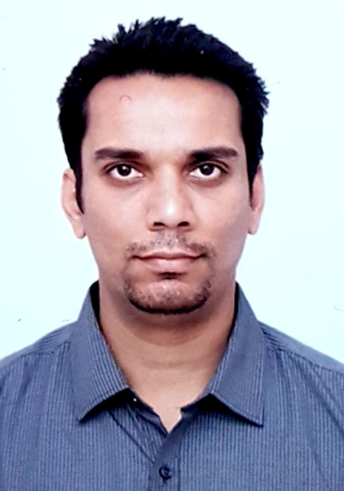
Zeeshan Qureshi

E-Mail: Zeeshanqureshi88@gmail.com
Phone: +91 - 8200632741

OBJECTIVE
A goal-oriented professional targeting challenging opportunities in F&B Operations / Client Relationship Management / Operations Management/ Event Management in Hotels & Resorts / Travel / Facility / Marketing Management/ Business Development & Sales Management

PROFILE SUMMARY
- A Hospitality / Tourism / Event Management professional with nearly 8 years of experience in F&B Operations, OTA Management (Like Booking.com,hotel.com etc..) , Faciltiy and Event Management, Business Development & Sales, Team Management and Cross Functional Team Experience
- Proficient Business Analyst with strong investigative and analytical skills, which helps to identify problems and opportunity with the company that helps to achieve the business goals.
- Expert in menu planning, inventory management and maintenance of a hygienic & safe environment
- A keen communicator with honed interpersonal, problem solving and analytical skills

CORE COMPETENCIES

Business Analyst Manager Skills
Business Planning Interpersonal Skills
Digital Marketing
Supply Chain Management
Leadership Skill
Training & Development

ORGANISATIONAL EXPERIENCE
FreshoHealthy, Ahmedabad
(April’21 – Till Date)
Business Owner

Role:
During Pandemic started a small venture of providing healthy food like Salads, Juices at Adani Shantigram Society and Near by Society.

Hospitality Essentials, Bhopal
(Nov’20 – Feb’21)
Operations Manager (Multiple Site)

Role:
Looked after Multiple Site like Adani, JPL, Nayara Energy
Looking After Business Analysis.
Making things work under budget.
Talking to Clients and solving there issues.
Looking after Food Costing, Maintaining the food quality, Solving problems of staff.
Arranging Events on Special Occasion.

OYO Weddingz.in, Ahmedabad (May’19 – Nov'20)
Venue Manager/ Sales Manager

Role:
Call all incoming inquiries / leads
Show the venue to all walk-in customers
Convert leads to visits and convert visits to bookings
Keep in touch with the customer
Coordinate with caterer and decorator to ensure all commitments are delivered
Maintaining a good relationship with venue owners and other stakeholders
Work with corporate team to market the venue and to execute any local marketing initiatives.
Achieve Monthly or Annually Targets.

OYO Weddingz.in, Gujarat (Dec’19 – March’20)
Business Development Executive

Role:
Helping BDM to meet venues across the State and share Weddingz.in value proposition
Work with city head to bring in partner venues on board at the right terms
Negotiate with venue owners to agree on terms favorable to Weddingz.in
Handover the signed venues to operations team for on-boarding
Maintain Report of Meeting done by BDM directly report to BDH (Project Owner)
Making of Contracts for BDM with Prior Approval of BDH.

Achievement:
Received “The Rising Star Certificate of Gujarat Circle” for the OND 2019 Quarter.

Bhookha Sher Restaurant, Bangalore (Pre-Opening) (Sept’18 – Mar’19)
Food and Beverage Manager

I have been involved with the complete setting up of an entire Restaurant (Offline and Online Portal) and its management and also in its running in Bangalore for the past Seven months.

Octagon Communications Pvt. Ltd. (Mar’17 – Jun’18)
Food & Beverage and Facility Manager

Role/Highlights:
Worked for two Projects:
- Vibrant Ceramics Expo and Summit 2017
- Vibrant Saurasthra Expo and Summit 2018
Coordinated and Managed International & Domestic Delegates, Celebrity’s Accommodations, Flights, Airport Pick up & Drop and Food & Beverage, Vendor and Facility Management

Wairakei Resort, Taupo, New Zealand (Sept‘15 – Nov‘16)
Food & Beverage Supervisor

Role:
Supervised food & beverage outlets for achieving efficient operations, maximum profitability and guest satisfaction at all levels
To initiate and introduce improvements in F&B controls; systems and procedures which are found necessary to ensure smooth running of Food and Beverage Control.
Controlled & monitored payroll costs by ensuring rosters were compiled in accordance with forecast & actual business levels
To periodically review receiving procedures and routines. To review with the general manager the performance of each kitchen and the food and beverage sales outlets.
To take corrective action whenever necessary and counsel the F&B Manager and the executive chef accordingly.
To plan the Standards & Specification for the food and beverage merchandise in consultation with the F&B Manager, Executive Chef, Purchase Manager and the Financial Control. And also review them on the regular interval
Complied with statutory and company requirements for health and safety, food safety, risk assessment and ensured all employment legislation were strictly adhered upon
To gather, process, analyse and present relevant data on the performance of the food and beverage department with appropriate comments to the management

The Langham Hotel, Auckland, New Zealand (Mar’12 – Sept‘15)
Sunrise Food & Beverage Attendant

Role:
Managed and Cross – Training :

Reservations/ Housekeeping/ Front Office
Room Service/ Restaurant/ Banqueting
Event Sales
Catering Sales

Organized the seating chart to eliminate chances of mismanagement at the time of guest arrivals
Liaised between guests and wait staff for ensuring proper understanding of guest requirements and demands
Checked & monitored the presentation of menus, decorum & ambience of the Food and Beverage and other department.
Formulated different measures and process to make guests feel welcome and relaxed (“Feel Like Home”)
Supervised the setting up for Banquet, Restaurant, Room Service, Club Lounge, Bar and High Tea.

Highlights:
Received:
‘You are Amazing’ Award once in Oct ’14 and twice in Apr ’15 for helping the HR for fulfilling the company objective of ‘One Team One Dream’
Outstanding Employee Certificate in May ’14 for successfully facing audits done by external hotel critics
Recognized as:
An Outstanding Employee in Jun ‘14
‘Someone Who Makes A Difference’ in Mar ‘13

TRAININGS
Completed:
‘The Barista Workshop’ Fundamentals-Online Theory Training in Sept ‘16
NZQA Unit Standards with focus on obtaining a basic knowledge of contamination hazards and control methods used in food business in Jun ‘15
Basic Chemical Safety On-Training in Apr ‘15
‘The Host Responsibility’ Course in Nov ‘14
LCQ (Licence Controller Qualification) recognized by Service IQ in May ‘15
“Code of Conduct Training” Course in March’20
“Anti-Bribery & Corruption and Anti Money Laundering Training” Course in March’20

