RESUME
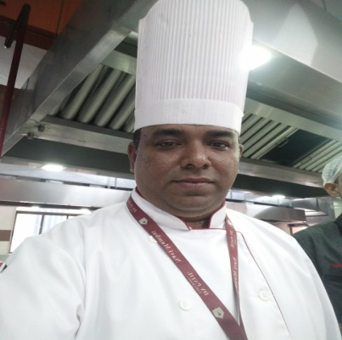
POST APPLIED FOR : GRILL/PASTA/PIZZA CHEF
NAME : SALVI SWAPNIL
FATHER NAME : MANMOHAN
DATE OF BIRTH/PLACE : 14TH OCT 1976, MUMBAI
NATIONALITY/RELIGION : INDIAN/ HINDU
GENDER/MARITAL STATUS : MALE / MARRIED
EDUCATIONAL QUALIFICATION: MSC IN HOSPITALITY & TOURISM
TECHNICAL QUALIFICATION: DIPLOMA IN HOTEL MANAGENT & CATERING TECHNOLOGY (3 YRS)
LANGUAGES KNOWN : ENGLISH, HINDI, MARATHI
E MAIL ID : swapnilsalvi25@hotmail.com
MOBILE : 7039501139
PRESENT ADDRESS : 102, SAI NIWAS, PLOT NO 55, SECTOR 24,
JUINAGAR, NAVI MUMBAI 400705
MAHARASHTRA, INDIA
EDUCATIONAL QUALIFICATION
DEGREE | UNIVERSITY/BOARD | PASSING YEAR | CERTIFICATE | PERCENTAGE
MSC | MADURAI KAMRAJ | 2019 | 428056 | 64(1ST CLASS)
DIP IN HOTEL MGT & CATERING TECH | MAHARASHTRA BOARD OF TECH EDUCATION | 1997 | 4598 | 62(1ST CLASS)

WORK EXPERIENCE
ORGANISATION | LOCATION | DEPARTMENT | ON DATE | OFF DATE | POSITION
DY PATIL UNIVERSITY  (RESTAURANT, CAFE ACROSS CAMPUS) | MUMBAI | FOOD PRODUCTION | 22/08/2016 | TILL DATE | SOUS CHEF
RED SEA HOUSING  KOREAN DINER | SAUDI ARABIA | FOOD PRODUCTION | 15/11/2015 | 10/07/2016 | SOUS CHEF( REMOTE CATERING)
SP MORE IHMCT | MUMBAI | FOOD PRODUCTION | 12/05/2013 | 12/05/2015 | SOUS CHEF
BURGS, SPECIALITY BURGER RESTAURANT | MUMBAI | FOOD PRODUCTION | 13/03/2012 | 10/05/2013 | SOUS CHEF(QUALITY & PRODUCT DEVLOPMENT)
FOOD FAYRE & MOCHACHOS  MAXICAN RESTAURANT | ZAMBIA | FOOD PRODUCTION | 15/08/2010 | 31/01/2012 | EXECUTIVE CHEF( 3 OUTLETS)
MOCHA  SPECIALITY RESTAURANT | INDIA | FOOD PRODUCTION | 23/03/2007 | 12/03/2010 | SOUS CHEF( FINE DINE)
BB’ S COFFEE & MUFFINS  SPECIALITY CAFE | UNITED KINGDOME | FOOD PRODUCTION | 31/1/2006 | 12/02/2007 | SOUS CHEF( SPECIALITY CAFE)
JAKE”S GRILL  MOTEL & GRILL CAFE | UNITED KINGDOME | FOOD PRODUCTION | 17/11/2005 | 27/1/2006 | PIZZA & GRILL CHEF
PUCCINO” S  EUROPEAN TAPAS & PASTA BAR | UNITED KINGDOME | FOOD PRODUCTION | 12/8/2004 | 21/10/2005 | TAPAS & PIZZA CHEF
THE CORNWALL  GREAT WELSH PUB | UNITED KINGDOME | FOOD PRODUCTION | 31/1/2002 | 31/7/2004 | ROAST & GRILL CHEF
ZAIKA  FINE DINE MULTICUISINE RESTAURANT | INDIA | FOOD PRODUCTION | 23/7/1997 | 25/1/2002 | TRAINEE CHEF- COMMI 1

DOCUMENTS DETAILS
DOCUMENT | NUMBER | ISSUE DATE | VALIDITY | ISSUE AT
PASSPORT | N2939218 | 08/09/2015 | 07/09/2025 | MUMBAI
INDIAN CDC | MUM 439212 | 09/09/2021 | 08/09/2031 | MUMBAI
INDOS | 11SL1485 | 06/08/2021 | 05/08/2021 | MUMBAI

STCW COURSE DETAILS
COURSE | CERTIFICATE NO | ISSUE DATE | VALIDITY | ISSUE AT
P S T | 20402761012103011 | 23/08/2021 | 22/02/2023 | NAVI MUMBAI
FPFF | 20402761012103011 | 23/08/2021 | 22/02/2023 | NAVI MUMBAI
EFA | 20402761012103011 | 23/08/2021 | 22/02/2023 | NAVI MUMBAI
PSSR | 20402761012103011 | 23/08/2021 | 22/02/2023 | NAVI MUMBAI
PST SDSD | 20402766212103012 | 20/08/2021 | NA | NAVI MUMBAI

PLACE: MUMBAI
DATE : 13/12/2021
SIGN:

