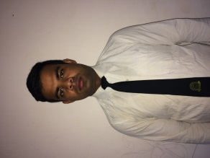
Sudhir Kumar Kushwaha
Vill.+ post- Takkipur, dist.-siwan, p.s- maharajunj,
Bihar, 841244
Contact No :- +91 8210328462
E-mail :- sk20011996@gmail.com
Skype Id :-

Profile:-
An assertive communicator who is adaptable to different work environment and believe in tenaciously handling responsibilities with versatile approach. Seeking opportunity in Food and Beverage Production department in an esteemed hotel.

Academic Qualification:-
- Completed Diploma in Food Production from IHM, Hajipur, patna
- Passed 12th from Bihar board U.S.S college Jalalpur, Siwan
- Passed 10th from C.B.S.C board, Hathwa, Gopalgang

Industrial Exposure Training
• Presently I am Working inCOUNTRY CLUB RESORT CHENNAI COMMI3
•. 3 Month Worked at HOTEL AMALFI GRAND PATNA COMMI <. •. Successfully completed 24 Weeks Industrial Exposure Training at LEONIA HOLISTIC DESTINATION HYDERABAD
Key Strength:-
- Excellent culinary skills along with a good understanding of different ingredients
- Capable of managing to cook for a large buffet within stipulated time
- A quick learner and adaptable to change
Computer Proficiency :- Ms - Office

Language Proficiency :- English, Hindi

Area of Interest :- Food and Beverage Production ( continental kitchen)

Hobby :- love cooking food

Personal Details :-

Name :- Sudhir Kumar Kushwaha
Father’s Name :- Rama Shanker Prasad
Date of Birth :- 20 Jan. 1996
Martial Status :- Single
Address :- Vill.+ post- Takkipur, dist.-siwan, p.s- maharajunj,
Bihar

