Sayam Anwar 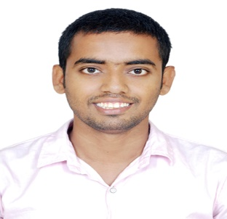
Jaggi ka chowraha, Mogulpura, Patna city, Bihar, India, 800008
Mobile number- +917461025417, 966550412560
Email address – ma5333096@gmail.com & ihm758915@gmail.
I Took both dose of vaccine
- Professional chef with 8years of extensive experience in Garde manger, Indian cuisine, Continental Cuisine, Italian Cuisine, Lebanese cuisine and Breakfast. Implementing seasonal ingredients and modern techniques.
- I have experience in pre-opening in Double Tree by Hilton and The Panache.
- I have experience in Hospital Catering also.
- I know costing , ordering , yield etc
- Follow SOP , HACCP etc.
Professional experience
- Currently Working as a Sous Chef in Sparsh Hospital , Bangalore (March 2021 to till yet)
- Working as a CDP in Double tree by Hilton, Mecca, Saudi Arabia (from 27th June 2019 to dec 2020 ).
- Working as a DCDP in Dana Beach Resort , Al Khobar, Saudi Arabia (03rd Nov 2016 to 03rd November 2018)
- Working as a Commis 1st in Golden Tulip Resort, Al Khobar, Saudi Arabia (07th August 2014 to 07th August 16).
Working as a Commis 2nd in The Panache, Patna (21st Janurary 2014 to 25th July 2014).
- Working as a Commis 3rd in The Chancery Pavilion, Bangalore (15th June 2013 to 15th December 2013).
- Working as a Industrial training in The Picadilly, Lucknow (December 2011 to April 2012).
Professional Education
- Pursuing Master of Tourism & Travel Management from IGNOU.
- B.sc in Hospitality & Hotel Administration from IHM, Hajipur (course co- administrated by I.G.N.O.U and National Council For Hotel Management & Catering Technology, Pusa, New Delhi, under Ministry of Tourism, Govt. of India (July 2010 to May 2013) .
Education Qualification
- Intermediate (Science) from B.S.E.B Board in 2009.
- High School from I.C.S.E Board in 2007.
Award and Achievement
- I have work experience in pre-opening hotel Double tree by Hilton, Mecca, KSA & The Panache, Patna.
- Got employee of the month in Dana Beach Resort.
- Participated in Chef competition & Food festival organized by college.
- Received appreciation letter for good work and 100% attendance during IT.
Strength
- Leadership skills, Teamwork, Humorous, Self-motivation.
Personal Details
- Date of birth 15th june 1992
- Height 5ft 8inch
- Gender Male
- Marital status Married
- Languages known English, Hindi, Arabic & Urdu.
- Passport issue date 08th August 2012
- Passport expire date 07th August 2022
- Passport number k4089871
Computer Proficiency
- Basic knowledge of Excel, MS word & MS PowerPoint.
- Basic knowledge of Internet surfing.

Place- Patna Sayam Anwar

