Curriculum vitae

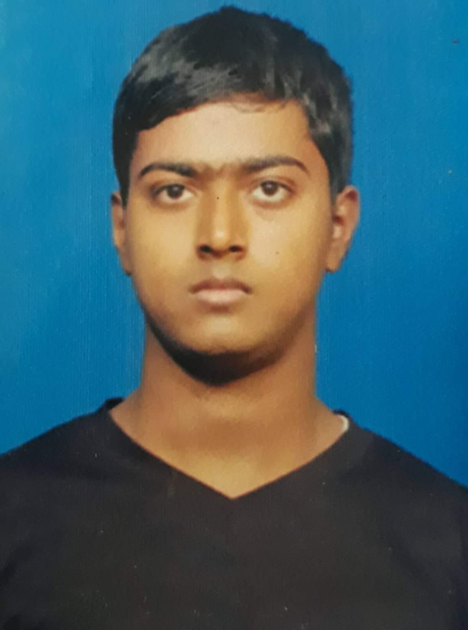
RANJAN KUMAR DASH
C/o- Harekrushna Dash
At- Mallipadar, Po- Mallipadar
Dist- Khurdha
State- (ODISHA) PIN – 752061
E-mail –ranjandash208@gmail.com
Mobile No- +91-8249992370
Passport no-R3046657

CAREER OBJECTIVE:
- I am highly interest in working under it should also give me responsibility and opportunity to make a difference,as I believe challenges make me to deliver my best,my greatest as are my sincerity and honesty.
PROFILE:
*I am reliable dependable and conscious of duties & responsibilities flexible team player,who will work laced.
AREA OF SPECIALIZATION:
*food & beverage production department(indian curry cuisine)
EDUCATIONAL QUALIFICATION:
10th Passed in Odisha in the year 2012 Kantabada high school Kantabada.
+2 Passed in Odisha in the year 2014 at ramamani Maha vidyalaya College, Kantabada.
PROFESSIONAL QUALIFICATION
Hotel Management for 1 ½ Year Diploma from IHM College of Hotel Management Bhubaneswar (ODISHA)
WORKING EXPERIENCES:
- Worked as sarovar portico, somnath(Gujurat)as a d-cdp from September 2020 to April 2021.
- worked as a CLUB MAHINDRA SAJ RESORT,MAHABALESWER (maharastra) as a commi-I from MAY 2019 to July 2020.
- worked as a THE FERN RESIDENCY, SOMNATH (GUJRAT) as a COMMII-II from OCT 2017 to Oct 2018.
- Worked as a MAGNOLIA RESORT VIRAJPET (COORG) as a COMMI-II from OCT 2016 to SEP 2017.
- Worked as a HOTEL CRYSTALIN (CHIL MANGALORE) as a COMMI-III from NOV 2015 to APRL 2016.
- IT Four months in MAYFAIR PALM BEACH RESORT (GOPAL PUR) a group of ( ODISHA) from date JUNE 2015 TO SEP 2015.
- INDUSTERIAL TRAINEE SWOSTI PREMIUM HOTEL on BBSR ( ODISHA ) from DEC 2014 to JAN 2015.
AREA OF INTEREST
* Make new dishes
* Collecting receipes

STRENGTH
*Fast Learner and Hardworking
*Pleasant personality with positive attitude and confident
*Honest creative, problem solving and keenness to learn
*Good decision maker.
PERSONAL PROFILE
Name : Ranjan Kumar dash
Father’s Name : Mr. Harekrushna Dash
Date of Birth : 20th May, 1997
Sex : Male
Marital Status : Unmarried
Religion : Hindu
Nationality : Indian
Category : General
Language Known : Oriya, English & Hindi
Blood group :(O+)
(PASSPORT DETAILS)
Passport no :R3046657
Date of issue :09/10/2017
Date of expired :08/10/2027
HOBBIES:
Playing Cricket,watching movie and listening music.
DECLARATION
I do here by declare that the above information is true to the best of my knowledge and belief.
Place:
Date:06/03/21 Ranjan kumar dash

