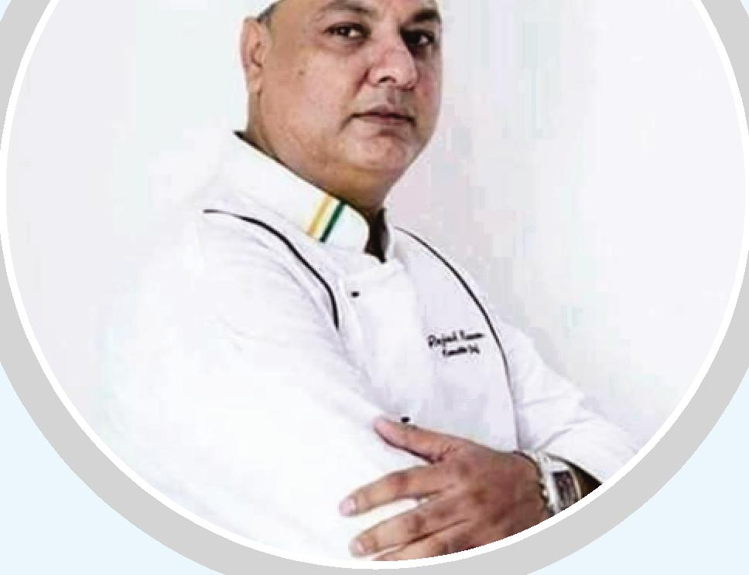 | RESUME  RAJESH KUMAR (Master Chef)  S/o. Mr. Panna Lal Sharma  (Gold Medalist India Chef, Personal for Indian President)  74, Govind Park, P.O. Krishna Nagar, Delhi-110051 (INDIA)  Tel : +91-9717996870 E-mail : chefrajesh101069@gmail.com  www.namasteyindiahospitality.com

Personal Information
Date of Birth Nationality  Languages Known Hobbies | 10th October, 1969  Indian  English - Hindi - Punjabi  Cooking & Cooking Books, Desire in Doing Food Festivals in All World

Academic Information
- 10th Passed in 1988 from C.B.S.E.
- 12th Passed in 1990 from C.B.S.E.
- B.A. Pass (1Ind Year) from University of Delhi in 8th Oct, 1992 Dropped in Last Year Having Mark Sheet
Professional Information
- Hotel Management, Training from Hotel Imperial From 01-08-1991 - 31-07-1997
: (v) Completed B.T.C. Apprenticeship Training from
Pusa Institute, Delhi Dtd. 31-03-1992
Contd ... 2

Work Experience

Presently Providing Hospitality Professional Services, Consultation for Opening Restaurants, Food Festivals & Spl. Street Food, Management cooking Workshop for all hotel Staff in India & Abroad, Outdoor Catering

SI. No. Hotel
As Trainer
As Trainer Consulting Chef Demi Chef De Parte Consulting Chef Senior Chef De Parte Demi Chef De Parte Executive Chef Executive Chef Executive Chef
Chef De Parte
Master Chef
Head Chef (Corporate Chef) Master Chef
Master Chef Master Chef Master Chef Corporate Chef Master Chef
Executive Senior Chef Executive Chef Executive Chef Executive Chef Executive Chef
Food Consulting Chef Executive Chef
- B.T.C. Pusa (Leaving Certificate)
- Hotel Imperial
- Hotel Maya Palace, Chandigarh, PB
- Indian Caterers Limited, Hongkong
- Samuel Fitze & Co (P) Ltd., Kolkata
- Hans Plaza, New Delhi
- Hotel Le-Maridian, New Delhi
- Shamiana Cuisines of India
- Employment Relation Service
- Oxygen Pub & Restaurant
- World Trade Tower - Group of JUMEIRAH INTERNATIONAL, U.A.E. (DUBAI)
- India Gate, Indian Cujisine, KOREA
- Ohri's Basera
- Milan Benquet
- Akshay India Cuisine
- Temptations
- Amber India Restaurant
- India Gate
- Paras Restaurant, Korea
- Fortune Hotel, Ahmadabad
21 Arabesque, Korea
- Kohinoor Restaurant, Korea
- Aamchi Mumbai - Hongkong
- Hotel Eden
- Taj Mahal Restaurant Japan
- Oshwal fine Dining Cuisine
Period
31st Aug. 1992
Contd ... 3
1st Aug. 1991 - 31st July, 1994 1st April. 1996 - 26th April, 1997 12th Nov., 1996 - 10th April 1997 13th Dec., 1997 - 23rd Mar, 1998 1st Aug 1991 - 31st July, 1995 4th Jan 1999 - 10th Mar, 2000 24th Feb 2001 - Cerfificarte
1st Spet 2001 - 5th April 2002 1st Aug, 2002 - 31st Dec., 2004 24th Feb 2003 - 5th Aug 2003
4th Aug, 2004 - 8th Feb, 2005 6th May 2005 - 15th Feb 2006 19th Nov 2006 - 31st May 2009 Oct., 2008 - 12th Aug. 2009
17th Aug., 2009 - 10th Nov., 2009 20th Nov 2009 - 12th Jan., 2010 19th May 2010 -19th Aug., 2010 31st Mar 2010 - 9th Aug., 2011 3rd Dec 2012 -15th May 2013 26th May 2013 - 03rd May - 2014 10th May 2014 - 14th Sep., 2014 19th Dec., 2014 - 10th, Dec., 2015 Dec., 2015 - March, 2016
May, 2016 to Jan., 2017
Present July, 2019...

Recipe & Interviews Published it
Contd ... 4
Some Famous News papers & Television Shows
SI. No. Details Article Published on Dtd.
 | The Asian Age, Kolkata | Parampara of Jicy Kabab | 12th Mar., 1998
 | The Telegraph, Kolkata | The City Graph | 17th Feb., 1998
 | Mandi Reporter, Delhi | Parampara (Khand and Chef) | 18th June, 1998
 | The Devonport, Flagstaff (New Zealand) | Only the Best Curies at Sages | 23rd Aug, 2001
 | HT City Indian, Delhi | Yet another Bar to make Tipplers Happy | 29th Aug., 2002
 | Rashtriya Sahara, New Delhi | City Halchal | 6th, Sept., 2002
 | Delhi Mid Day, India | Shake your Bon-Bon | 5th Dec., 2002
 | Delhi Mid Day, India | Unlimited Kababs Festival | 11st Dec., 2002
 | HT City, India | Five things your must to today | 13th July, 2003
 | Gulf News Tabloid, World Trade Centre, Hotel Dubai | Masala | 30th July, 2003
 | Khaleej Times, Dubai | Kababs Fit for Kings | 5th Aug., 2003
 | Khaleej Times, Dubai | Davinder Kumar's (Recipe Book)
 | Kabab Chutney & Breads | Focus on India Gate | 4th Sep., 2002
 | Friday (Korean Magazine) | Master Chef Interview | 6th June 2002
 | Food Journal (Korean Magazine) | Master Chef Interview | March, 2005
 | Driving for Fun (Korean Magazine) | Master Chef Interview | April, 2005
 | Seoul Free Classified | Master Chef Interview | 27th Nov 2004
 | Withus (Korean Magazine) | Master Chef Interview | June 2005
 | My Weekend (korean Magazine) | Master Chef Interview | 11th Nov., 2004
 | Good Week (Korean Magazine) | Indian Royal Authentic Cuisine in Seoul | 1-15 Dec., 2004
 | The BC (Korean Magazine) | Top Interviews with Indian Gate Rest. | March, 2005
21 | The Food Service Management | Master Chef Interview. | March, 2005
 | Cartoon today (Korean Magazine) | Be Our 777th Guest Opening Festival | April, 2005
 | Sky Zine (Korean Magazine) | Master Chef Interview | April, 2005
 | In Style (Korean Magazine) | Master Chef Interview | 2005
 | Noblesse (Korean Magazine) | A Special Royal; Course at India Gate | 2005
 | Bistro (Korean Magazine) | Master Chef Interview | Julyh, 2005
 | The Dong-a libo | Weekend Master Interview | 2006
 | I Long Saturday (Korean Magazine) | Recipes Shahi Khumb Hara Dhania | 28th, Jan 2005
 | The Dong-a libo | Weekand Master Chef Interview | 8th, Jan, 2003
 | Dainik Jagran | Recipes, Ahmdabad, India | 28th Jan, 2005

Television Interviews

SI. No. T.V. Channel Programme
 | DD Metro I (New Delhi) Good Morning Metro Show - with Devesh Anand - Pranav Motion Picture | Interview
 | DD Metro II (New Delhi) Good Morning Metro Show - with Devesh Anand - Pranav Motion Picture | Good Morning Metro
 | Alfa TV Punjabi (New Delhi) Food Festival Interview | Interview
 | MM TV News (Hyderabad) Food Festival Interview | Interview
 | Menupan (Food Channel) Korea | Interview
 | KBS I TV (Korea) | Interview
 | KBS II TV (Korea) | Interview
 | Media Communication Broadcasting Prod. | Interview
 | Satville - Sekwang TV | Interview
 | KTF TV Channel | Interview
 | ZEE News (Food Festival) N. Delhi | Interview
 | Home Shopping (TV Show Korea, India Gate | Interview

ACKNOWLEDGEMENTS

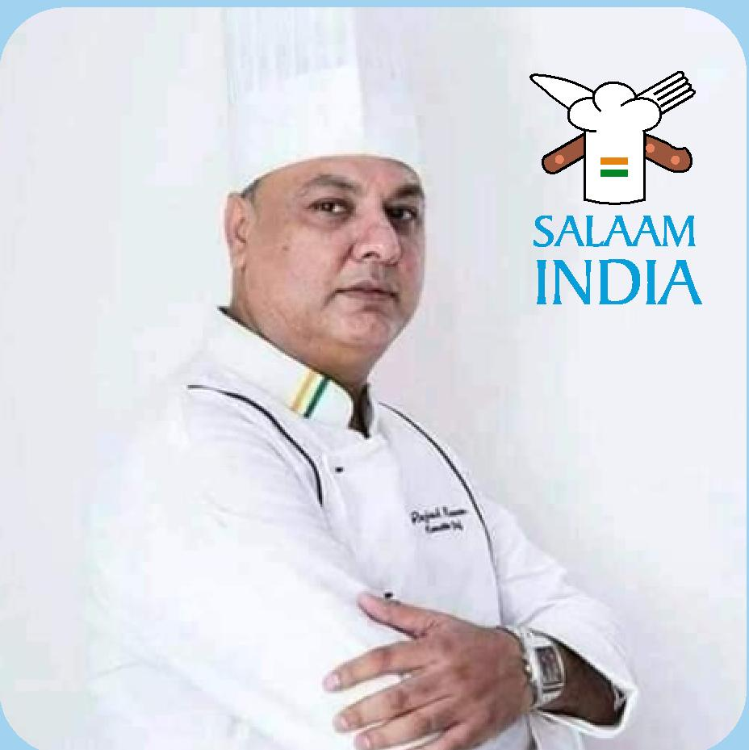
Rajesh Kumar
Senior Executive Master Chef
Go Bindas
Korea Teaching Chef Rajesh Kumar
"t_{it::} Salaam India Hospitality www_{h} www.masterchef rajeshkumar.com N4:12V Local Address Contact Vimla Trivedi: 31, B
Champaner Society, Usmnapura, Ahmedabad-380013
Mob. : +91-9726246209, +91-9737299260

I am specially indebted to the following Kitchen masters
for contributing recipes and helping to perfect. them:
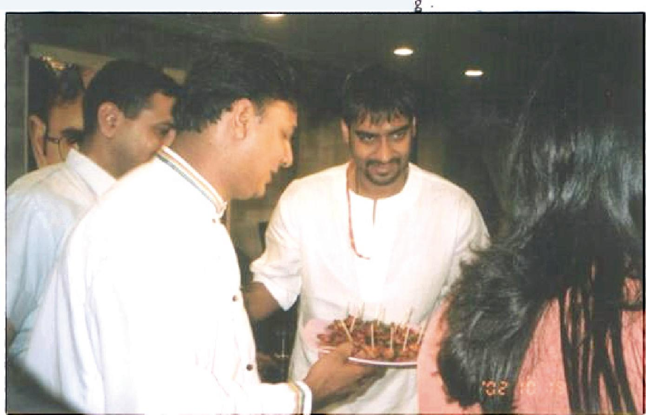
CHEF RAJESH SHARMA
Acknowledged to be a master tandoori chef.
a reputation earned at Le Meridien, New Delhi.
Chef Sharma is the third generation of chefs coming
from a family of well-known chefs. His father.
Mr. Parma Lal Sharma is a well known chef. A graduate
from Delhi University. he has been in this profession
for the last 12 years. Over the years he has worked
in India and abroad. He is an expert in the art of
Tandoori cooking
and is called The Kebab Kin

