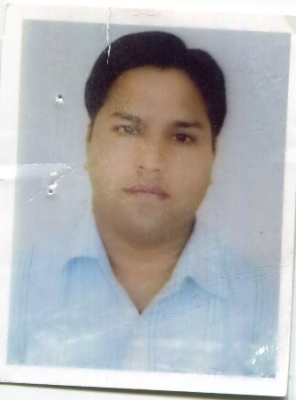
Naresh Chandra Ranakoti
Chef de Partie le Meridien Gurgaon
Mobile:+919873308426
E-mail: naresh234568@gmail.com

Career objective:

To obtain a challenging position in the area of hospitality development, where my skills and creativity can be utilized in maximizing company profits while providing career advancement opportunities.

Work experience

15 years of experience in hospitality industry in Food Production department with knowledge and quality

❖ presently working. Le meridian hotel Gurgaon India as chef de parties 08 Fab 2021 to till date
Duties and Responsibilities:
Responsibleforcookingqualityproductsandpreparingqualityproductstoexactrecipe.
Assisted barker chef, food costing wastage control
ResponsiblefordailyMiseenplusandcleantheallthewalk-InChillerandfreezer Responsible o rallthe food items leaning and washing vegetables items.
Responsible forallthe food items costing production control.
EnsuredkitchenareasareconstantlyClean-ranges,Cooler,Freezer,Mixer,Slicer,Floor,Dishwashing,Pots&Pans, Garbage ,Recyclables ,etc..

.❖ Ghaya grand hotel in Dubai as a chef de parties 30 December 2019to 30 Jun 2020 to covid 19

❖one and half year working olive roots restaurant Dubai as a chef de parties from 3 April 2018 to 28 December and 2019

❖ working Anya hotel Gurgaon as a chef de parties from 05 Dec 2016 to 31 march 2018

❖ working pind Baluchi restaurant Gurgaon as a unit chef from
26 oct 2016 to03 decembe2017

❖Three year working anya hotel gurgaon as a Demi chef partie 15nov 2012 to24 Oct 2015

One year woking I T c fortune Chettarpur New Delhi as a commi-I 10 Sep-2011 to 13th October 2012.
❖ Two year Workeing with L.O.N.C. in Qutab hotel branch soul vacation hotel colva beach Goa in Indian curry commi-II, form 1st feb 2007 to 12 dec 2009

❖ Worked in Infusion fine dining restaurant in Gurgaon form 24-12-2009 to 6 Aug-2011(branch to Maurya Patna) commis-I

EDUCATIONAL QULAIFICATION

Six month I industrial training president hotel dehradun india

❖ High school from U.P Board in year 1997
❖ Intermediate from U.P. Board in year 2000
Six month industrial training hotel president dehradun

❖ One- half years Diploma in hotel management catering.
❖ Technology and applied nutrition from Himalayan
❖ Institutes of Hotel Management (DEHRADUN)2006-2007
Response Balti

Responsible standard under the guideline of executive chef in pre-opening
Responsible for the indian Section
- Daily indenting, placing and receiving of market orders, daily inventories.
- Responsible for the maintenance and hygiene according to the standards in the kitchen.
- Taking care of Hot-section mise-en-place and services.
- Interacting with guests during meal periods to get feedback.
- Worked in malticusion r as well.

Areas in which I can work

Indian section
kitchen hot kitchen

Personal Profile

Date of birth 24th February 1981
Father’s name Sri Lungi Ram Ranakoti
Marital status Married
Nationality Indian
Language English and Hindi

Summary
My long term goal is to join a company that offers the potential for experience and growth as well as stability. I work well in a fast paced, high pressure environment, and feel I would be a contributing asset to your company.

Declaration

I hereby declare that the information furnished above is true to the best of my knowledge.

( NARESH CHANDRA RANAKOTI)

