Curriculum Vitae 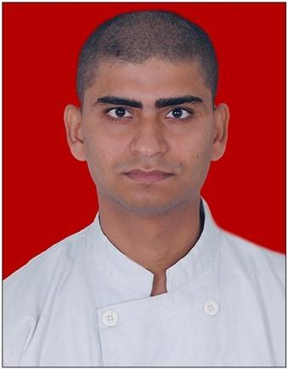
MANJEET JHA
Contact no: 9717019356
E-mail: manjeetjha132@gmail.com

CAREER OBJECTIVE

To Pursue a Challenging Career And be a Part of Progressive Organization That Gives a Scope To Enhance my Knowledge And Utilizing my Skills Towards The Growth of The Organization.

EDUCATIONAL QUALIFICATION

- BA-ICA in Hospitality Studies from ITM-IHM, Affiliated to Mumbai University in 2018.
- Senior Secondary School Examination from CBSE in 2014.
- Higher Secondary School Examination from CBSE in 2011.

TRAINING & EXTRA CURRICULUM

- Done 6 months industrial training only in the Food Production Department from IBIS Hotel Jaipur, In 2016.
- DONE degree (BA-ICA) Bachelor of International Culinary Arts, from ITM-IHM, Nerul Navi (Mumbai) . Collaboration with Queen Margaret University\ Mumbai University. In 2015-2018.
- In 2018 Working With Ace Manor Hotel (GHAZIABAD, UTTAR PRADESH) From (April 2018 to December 2018) At a post of Commi 3 In Kitchen Department.
- Working With Red Fox By Lemon Tree Hotels GOA. As a post of Commi 1, From(11April 2019 to 15 june 2020).
- Joined KFC as a Management Trainee from 16 September 2020 to July 2021.

PERSONAL INFORMATION
Name: Manjeet Jha
D.O.B:- 19/08/1995
Gender: Male
Marital Status: Single
Nationality: INDIAN
Languages Known : Hindi, English and Maithili.
Hobbies : Playing Badminton, Reading News Paper, Cycling
Address : 242 D, Super Mig, Express View Apartment ,Sector-93 , Noida (Uttar Pradesh)

