Chef Vijay.R. Challa. + 91–902 231 9692
+ 91-889 846 0090
vijaychalla84@gmail.com
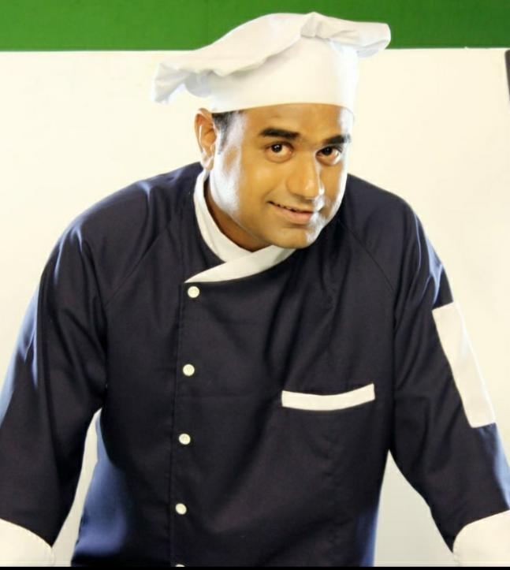

RESUME
CAREER GROWTH
- Worked At Retail Hub Hospitality Service to Raymond Company
POSITION: Senior Sous Chef.
RESPONSIBILITY: Corporate Catering, Ala Carte, Banquets, Conference Meetings, Outdoor Catering, Cafés, Wine Dinner, Body Art, Raymond Guest House, Raymond Reality & SCC - SOC
Duration: 5Th April,2017 To till Date.

- Worked At Devyani International Limited “RJ CORP” (Andheri) With Chef Sanjib Sarkar
POSITION: “Senior CDP"
RESPONSIBILTY: Amex fine dine, Carnation, Lounge, Foodies Bar & Main kitchen
CUISINE: Indian Regional and North frontier, Continental and Oriental
Duration: 15th June 2010 to 31st December 2016

- Worked At Radhakrishna Hospitality (SODEXO) Mr SPOONZ Jogeshwari With Chef Chandrakant
POSITION: Chef -De-Partie
RESPONSIBILITY: Corporate Catering like Hospitals, Corporate Offices and Schools
Duration: 16th^{th} March 2010 to 10th June, 2010

- Worked At Royal Caribbean Cruise Liner
POSITION: ‘Cook II’.
RESPONSIBILITY: Portofino, Chops Fine Dine Restaurant, Windjammer, Galley Roast Cook, Tournant Cook, Soup Cook and Garde Manger
Duration: 27th^{th} April 2007 to 28th^{TH} Feb 2010

- Worked At JW Marriott @ Juhu With Chef Ajay Chopra In Lotus Café
CUISINE: Continental, Thai And Indian Cuisine
POSITION: Commis II
RESPONSIBILTY: IRD , Lotus Café, VIP Lounge , Reflection Restaurant And Bombay Baking Company
Duration: 07th Aug, 2006 – 30Th March, 2007

- Worked At Café Basilico Bistro And Deli Mediterranean Cuisine (Colaba And Bandra)
With Chef Vinod Ghadse
CUISINE: Continental & Mediterranean Cuisine
POSITION: Commis III
RESPONSIBILTY: Grill and Pantry
Duration: 24th Jan,2006 – 04th Aug, 2006

- Completed Industrial Training At Taj SATS @ Andheri with Chef Satish Arora Developed A Cooking Skill In (Indian Cuisine, Continental Cuisine, Bakery, Pantry, Indian sweets And Snacks)
Duration : 27th June,2005 - 26th Dec,2005

- Completed Training At INDIGO DEGUSTIBUS (Colaba) with Chef Nitin Kulkarni Developed A Cooking Skill In Wine Dinner Pairing Foods And Italian Cuisine
Duration : 1st Jan, 2005 - 30th May, 2005

EDUCATION

- Pursuing MBA In Hospitality and Marketing from Welingkars Institute
In 2018
- Successfully Completed T.Y.BA from University Of
Mumbai (kalina) March 2013-2014.
- Successfully Completed Culinary Course
From Kohinoor Catering Institute. Dadar
(West) 2004-2005.
- H.S.C. (Higher Secondary School Certificates) 2001-2003 From Narsee Monjee College Of Arts And Commerce
- S.S.C. (Maharashtra State Board) 2000-2001 From Poddar High School

ACCOLADES

- Participated in Aviation Security Organized By
At CSIA Towards Programme Issued by Bureau of Civil
Aviation Security. 2010 - 2011

- Has Successfully Completed the Course of Crowd
Management and Appropriate Training 2010 - 2011

- Participated and Won the Inter-College Football
Tournament For “Kohinoor Catering Institute 2004 - 2005

- Represented in Inter-College Volley Ball
Tournament For “Narsee Monjee College”. 2002 - 2003

- Successfully Completed Road Safety Patrol
from Anandilal Poddar High School.
During the Year 1998 to 2001

SIGNIFICANT FUNCTIONS
PROFESSIONAL QUALIFICATION: COMPUTER PROFICIENCY
- Software : Microsoft Word, Excel, PowerPoint etc.

PROFESSIONAL QUALIFICATION: CRAFTMANSHIP COURSE
- Participated in Maharashtra Utsav Chef Contest and secured First place.
- Completed Successfully Completed Culinary Course from Kohinoor Catering Institute, Dadar (West)

PERSONAL DETAIL
Name :Vijay Rajesh Challa
Date of Birth : 08 March 1984
Age : 36 Years
Marital Status : Married
Nationality : Indian
Language Known : English,Hindi,Telugu, Marathi
Hobbies : Following Motivational Speech
Passport No : Z6142153

