 | AKASH RAJ SINGH  Old Sonari, MP road,  Jamshedpur - 831011, Jharkhand.  iihm18kol641_akash@iihm.ac.in  Mobile - +91 8119976757/+91 9006099012
  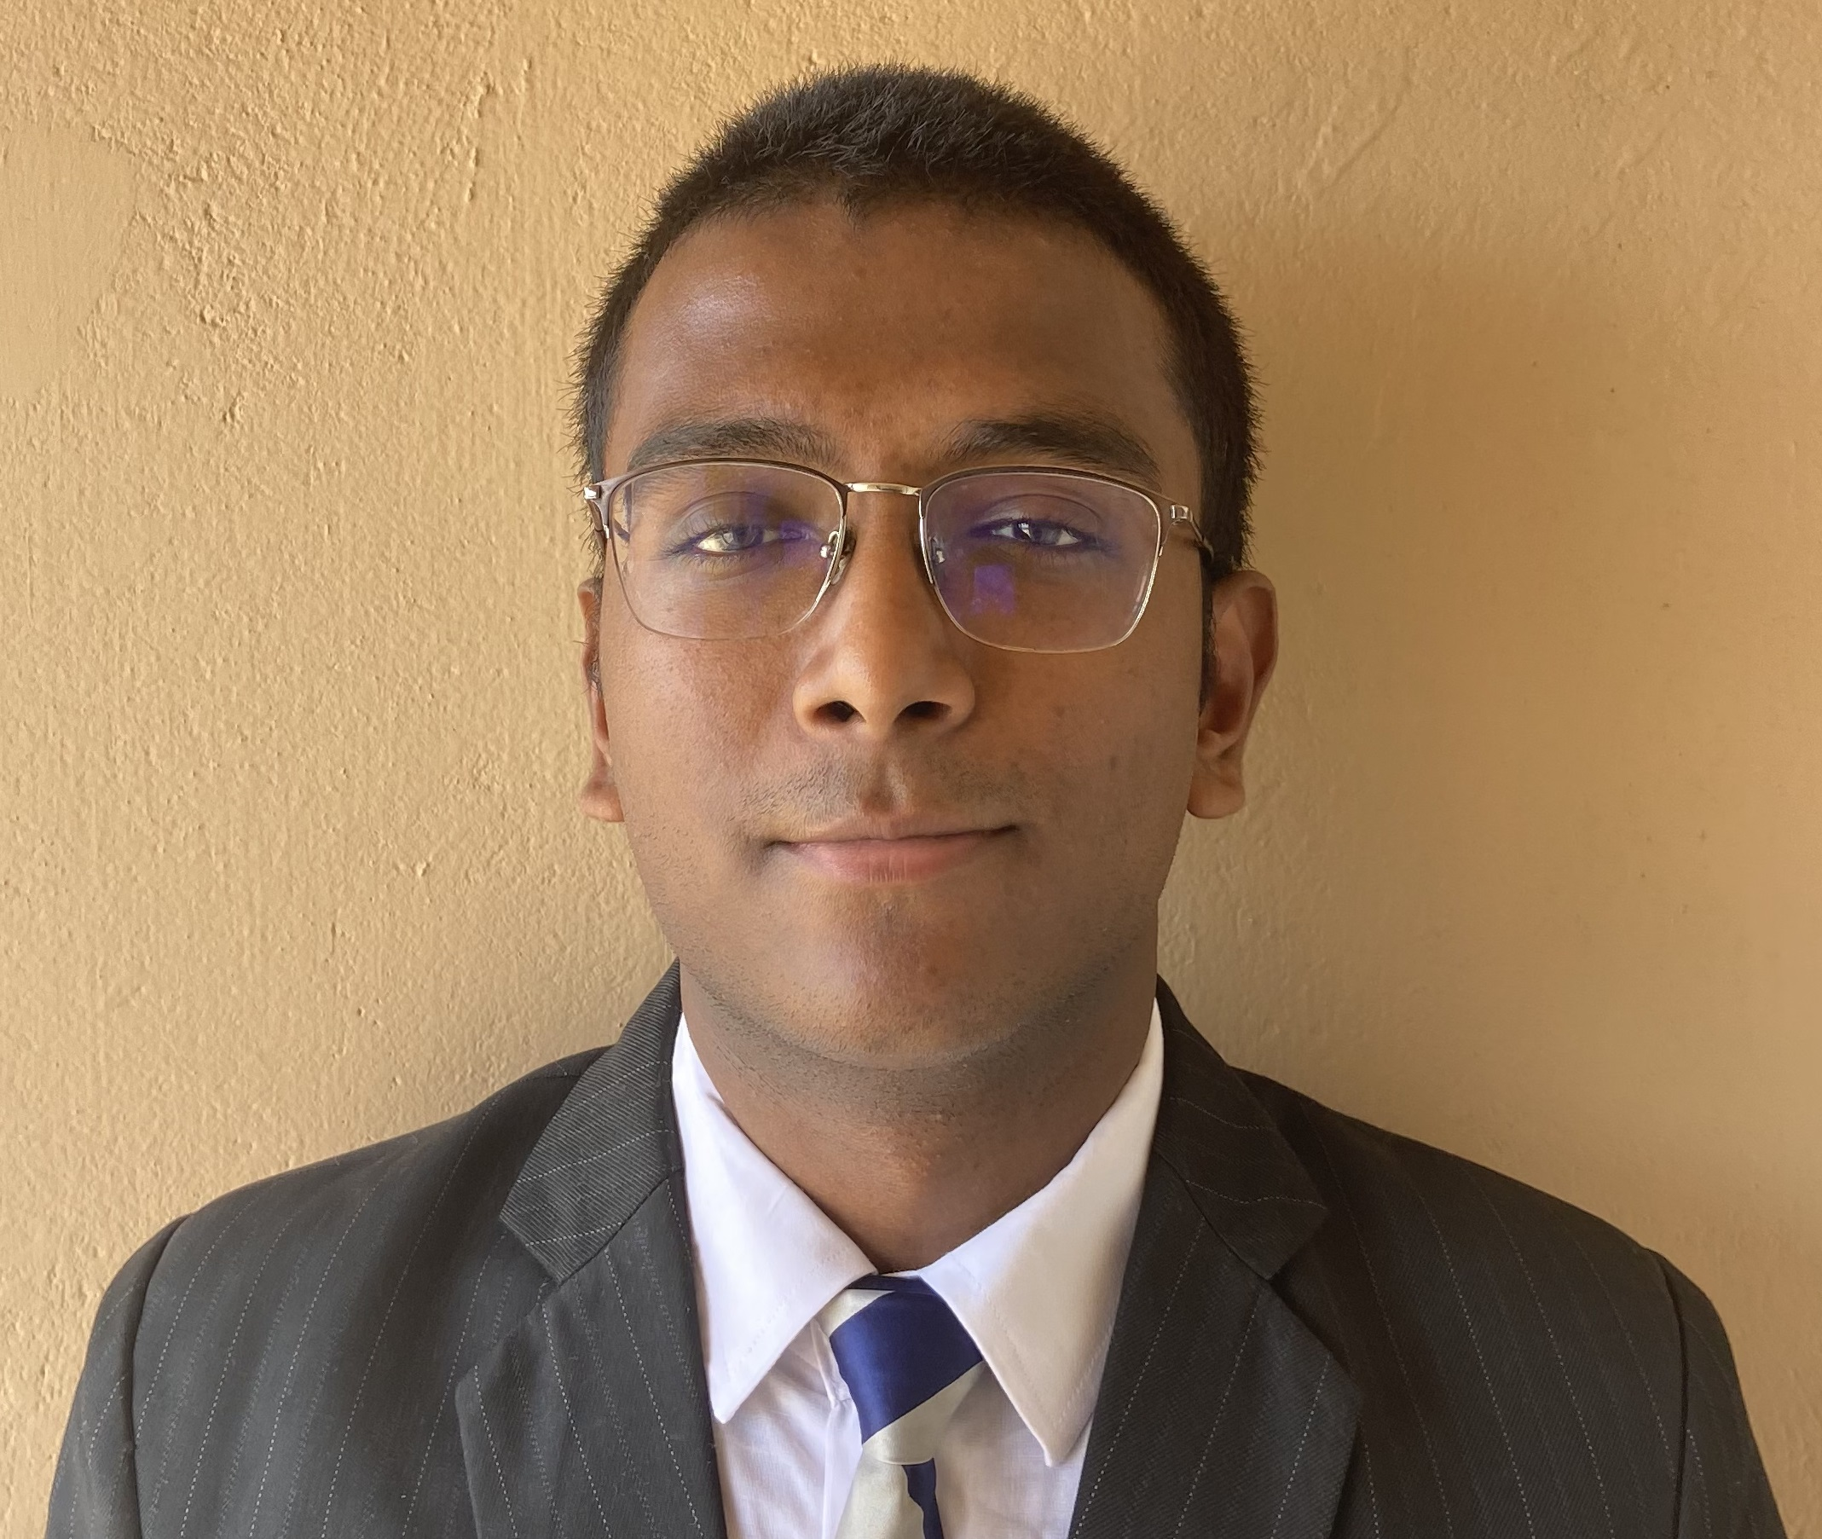
OBJECTIVE

A curious hotelier, I am strongly determined towards learning and upgrading myself day by day. Hard work and punctuality defines me the most at the work place. I am dedicated towards the growth of myself and the hotel at the same time. Service oriented and self motivated personal with the strong passion for hospitality business, an outgoing personality with profound skills, a team player with an optimistic and reliable attitude. The goal is to aim for excellence in the field of hospitality.
Service-oriented and self-motivated personal with a strong passion for the hospitality business. An outgoing personality with profound skills and meticulous eye. A team player with an optimistic and reliable attitude.
DATE OF BIRTH : 12 October 1999
EDUCATION
International Institute of Hotel Management |  | June 2018 – 2021
- Pursuing Advanced Programme in International Hospitality Administration
- Bachelor in Tourism Studies from IGNOU
Delhi Public School, Jamshedpur (Senior Secondary Examination) |  | March 2018
Delhi Public School, Jamshedpur (Secondary Examination) |  | March 2016
EXPERIENCE
The Ravenala Attitude, Mauritius  Industrial Exposure Training  Department: Food Production  Task Performed:  - Cleaned and maintained station to practice good sanitation & organizational skills  - Had proper understanding and knowledge of equipments used in the kitchen.  - Mis-en-place for various courses for the restaurant like salads and sandwiches.  - Learnt the proper techniques of cutting and also ways in which different cuts can be carried out.  - Preparing different types of pastas in Live Counter.  - Well specialized with Grilled Chicken in Live Counter.  - Setting up Breakfast and Lunch Buffets.  - Worked at TABA-J it is a local street food stall  - Worked at BBQ it is a grill station for seafood and meat  - Assisted the chef at RIVIERA is a seafood fine dine restaurant  - Assisted the chef at MADAM-MING is a Chinese speciality restaurant  - Setting and closing of at MOZAIK is a buffet restaurant for breakfast, lunch &dinner  On The Job Training: Indismart Group Of Hotels, Kolkata  Department: All Four.  Casual Training: IBIS, Kolkata  JW Marriot, Kolkata  Hyatt Regency, Kolkata |  | November 2019-March 2020  March 2019
LEADERSHIP AND CAMPUS INVOLVEMENT
Food Production Team Member at Food Festival  Participated & provided inputs for 500 guests |  | September 2019
Food Production Team Member at Rigolo  Planned and organized an inter-college fest with various events for 15 participating colleges |  | November 2019
Food Production Team Member  Planned the menu for ‘Realia’, an entrepreneurship activity; generated maximum revenue |  | July 2019
Coordinating Team Member at Young Chef Olympiad |  | January 2019
CERTIFICATIONS
Awarded with E Hotelier completion course in Design and cost Menus |  | January 2021
Certification for COVID-19 Awareness  IBM Design Thinking Course |  | January 2021  July 2021
OTHER
Skills: Decision Making
Profound Interpersonal Skills
Tact and Diplomacy
Creative
Customer Oriented

Languages: English
Hindi
Bengali

Interests: Photography
Sports
Movies
Travelling

LINKEDIN ID - https://www.linkedin.com/in/akash-raj-singh-b856a5208?lipi=urn%3Ali%3Apage%3Ad_flagship3_profile_view_base_contact_details%3BZDJNipFlTbmFnTl2C%2B%2BZ3A%3D%3D

