CURRICULUM VITAE

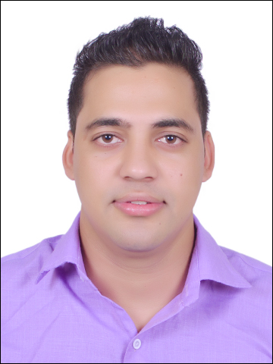

UMESH SINGH BISHT
FOOD AND BEVERAGE SERVICE
MOBILE- +91 8626065363
Email: - umeshsinghbisht455@gmail.com

CAREER OBJECTIVE:

To share and enrich my knowledge and experiences in the orientation of firm’s goals, and obtain an excellent career in Hotel industry

WORKING EXPERIENCE:

HOTEL NAME : THE LEELA AMBIENCE GURUGRAM
DURATION : FROM 17 JUNE 2017- 27 NOVEMBER 2021
CURRENT POSITION : BAR AND RESTAURANT SUPERVISOR
Spectra - All day dining restaurant of 225 covers.
Spectra an all day dining multi cuisine restaurant with 7 interactive Live counter and 3 private dining room.
INVENTORIES for wine,spirits,soft beverage,CGS, linen and restaurant supplies
RESTAURANTS AND BAR OPERATIONS
Upselling wines and food. Guest handling and satisfaction.

TRAINING DETAILS:

HOTEL NAME : RADISSION BLUE ALIBAGH, MUMBAI.
DURATION : FROM 15Th JUNE 2015 TO – 7Th NOVEMBER 2015.

RELEVANT WORK EXPERIENCE & SKILLS
- Day - to -day management of restaurant business.

- To maintain inventories of wine, spirit,soft beverage.

- Brief staff about the daily task to be done and ensure that the assignments are completed on time.
- Re-solve guest conflicts and implement change.
- Maintain computerized inventory control and sales.
- To attend the meetings & create new things and Implementing according to procedure.
- Encourage team work to boost the enthusiasm of the staff in achieving monthly targets of the restaurant.

ACHIEVEMENT:

- I got appreciation certificate from food & beverage service department during industrial training period.
- I got appreciation certificate for the guest satisfaction.

ACADEMIC PERFORMANCE:

COURCE | YEAR OF STUDY | NAME OF THE INSTITUTE | UNIVERSITY
High school | 2010-2011 | G.I.C Kathghariya haldwani  Nainital | NAINITAL
Intermediate | 2012-2013 | G.I.C Kathghariya haldwani  Nainital | NAINITAL
BHMCT, Bachelor in Hotel Management & catering Technology | 2013-2017 | Amrapali Institute of Hotel Management. | DEHRADUN

College : Amrapali Institute of Hotel Management, Haldwani Nainital
& Bachelor in Hotel Management & Catering Technology, 4 Year degree Programme, affiliated to Uttarakhand technical University, Dehradun.

Duration of course : 2013-2017

PROJECT:

Title : Study about alcohol and Beverages

COMPUTER PROFICIENCY:

- Diploma in advance computer software. (DACS)

PERSONAL SKILLS:

Innovative, comprehensive problem solving abilities, willingness to learn, smart working and flexible, Enthusiastic towards teamwork and goal orient.

INTEREST/HOBBIES:

My hobby is I like to travelling and visiting new place.

REFERENCE:

I would be glad to furnish the same as and when needed.

MY COMMITMENT:

If given an opportunity to perform for your organization from my end, I promise to offer a package of commitment, dedication, hard work and professionalism.

PERSONAL PROFILE:

Name : UMESH SINGH BISHT
Date of Birth : 02. 06. 1996
Father Name : SOBAN SINGH BISHT
Sex : Male
Marital Status : Single
Languages Known : English, Hindi
Nationality : Indian

PASSPORT DETAIL:

PASSPORT NO : P7968466

EXPIRY DATE : 30/05/2027

DATE OF ISSUE : 31/05/2017

PLACE OF ISSUE : DEHRADUN

PERMANENT ADDRESS : VILL- BACHINAGAR NO.1 P.O.-LAMACHAUR

HALDWANI, NAINITAL

UTTARAKHAND, INDIA

PIN: - 263139

DECLARATION

I hereby declare that the above written particulars are true to the best of my knowledge and belief.

Place: NAINITAL

Date: (UMESH SINGH BISHT)

